Table of Contents

Chapter 1 3
Current Technology 4
Design Specifications 6
Arduino Leonardo 8
Impact of this Design 10
Chapter 2 11
FAST Diagram 11
House of Quality and Critical Customer Requirements 12
Project Timetable 13
Chapter 3 14
Hardware Specifications 14
The schematic: 15
Design Specifications: The H-Bridge Chip 16
Hardware Implementation 19
Software Development 22
Software Development : Graphical User Interface(GUI) 31
Printed Circuit Board Design 38
Chapter 4 42
Testing for intended functionality 43
Test Results 44
Detenting 44
Stress Testing 44
Software/Keyboard Graphical User Interface(GUI) 45
Chapter 5 47
Appendix 1 50
Appendix 2 53
Appendix 3 54

Executive Summary

Every year in the United States, thousands of infants are diagnosed with Cerebral Palsy (CP), a group of disorders affecting nervous system and motor functions. There are several types of CP with varying levels of symptoms, ranging anywhere from abnormal muscle contractions and loss of coordination to partial paralysis and loss of speech capabilities. While most people living with CP are able to process information efficiently, they may not have the motor skills necessary to communicate their ideas with others. It is therefore a necessity that they have assistive technology that can form a medium of communication for them.
Our team was tasked with designing a joystick to function as the primary input interface to a computer for individuals living with Cerebral Palsy (CP). We have developed a programmable joystick that provides local support at designated positions, valuable in controlling the involuntary muscle spasms common to those with CP. The number of positions and the strength of the stabilizing mechanism can be selected by the user through a USB computer interface to meet the specific needs of different CP cases. The new joystick was completed on schedule, within our provided budget constraint. With this new design, people living with CP will now have a more efficient means of communication that is tailored to fit their specific abilities.

Acknowledgements

The team would like to extend tremendous thanks to their sponsor, Mr. Stephen Blosser. Without his guidance and resources, the prototype most likely could not have been completed. Mr. Blosser kindly built the housing for the joystick, and assisted in the mechanical portions of design. He also made his workshop available for the team’s use throughout the semester. Along with Mr. Blosser, John Eulenberg also provided his expertise on assistive software. We’d also like to thank Branden for being our inspiration and giving us the opportunity to work on such an insightful project.
Along with Mr. Blosser the team would also like to thank the following people for their guidance and assistance throughout the semester:

Robert McGough
Michael Shanblatt
Gregg Motter
Bryan Wright
Greg Mulder
Roxanne Peacock
Steven Noll
Asif Naseem
Erik Goodman
Karl Gude
All individuals who tested our keyboard user interface

Chapter 1

Branden’s Story

Cerebral palsy (CP) is a broad term encompassing a group of non-progressive neurological disorders. Each year in the United States, approximately 10,000 infants are diagnosed with CP, with another 1,500 children being diagnosed by the age of preschool. There is a wide range of severity seen among different cases of CP. One person may suffer from slight twitches or impaired balance, while another could have partial paralysis or completely lack the ability to speak. A key thing to note with CP is that in most cases, the person still has complete mental capacity; they simply do not have the fine motor skills necessary to communicate their thoughts with others. It is therefore necessary for these people to have some sort of assistive technology that can create a medium of communication.
One specific case of CP that is being targeted by our design team is that of Branden Bennett. Branden is a student currently attending Jackson Community College, with hopes to soon transfer to Michigan State University. He suffers from athetoid cerebral palsy, which causes unwanted muscle movements and interferes with his speech and fine motor skills. His condition restricts him to a wheelchair. Branden currently utilizes a type of assistive technology known as a mechanically detented joystick. He has been working carefully with it for some time but still has had some difficulties due to its limited tuning capabilities. In the next section, the exact functionality of the mechanically detented joystick will be examined in order to determine the necessary improvements that must be made.



Branden is seen here with some of his assistants. The team’s sponsor, Mr. Stephen Blosser, is standing on the far right.

Current Technology

As was stated earlier, there is an existing form of assistive technology for those with CP known as a mechanically detented joystick. A detented joystick is similar to other gaming joysticks on the market in that they serve as the primary input device for a computer. They also serve a secondary purpose, which is to provide users with local stability at designated joystick positions. This is crucial to those with CP, who lack the fine motor skills necessary to properly work with a joystick. Detenting essentially allows a user to more effectively remain on a desired option and select it without being impeded by uncontrolled muscle tremors commonly seen in those with CP. In short, it is a noise filter to involuntary muscle movements. The detent positions are generally defined on points of intersection of a square matrix. The number of detents is largely dependent on the severity of muscle tremors. Often times, someone with CP may start by using a joystick with fewer detents (i.e. 4x4 matrix), and gradually work their way up to a larger workspace (i.e. 10x10 matrix).

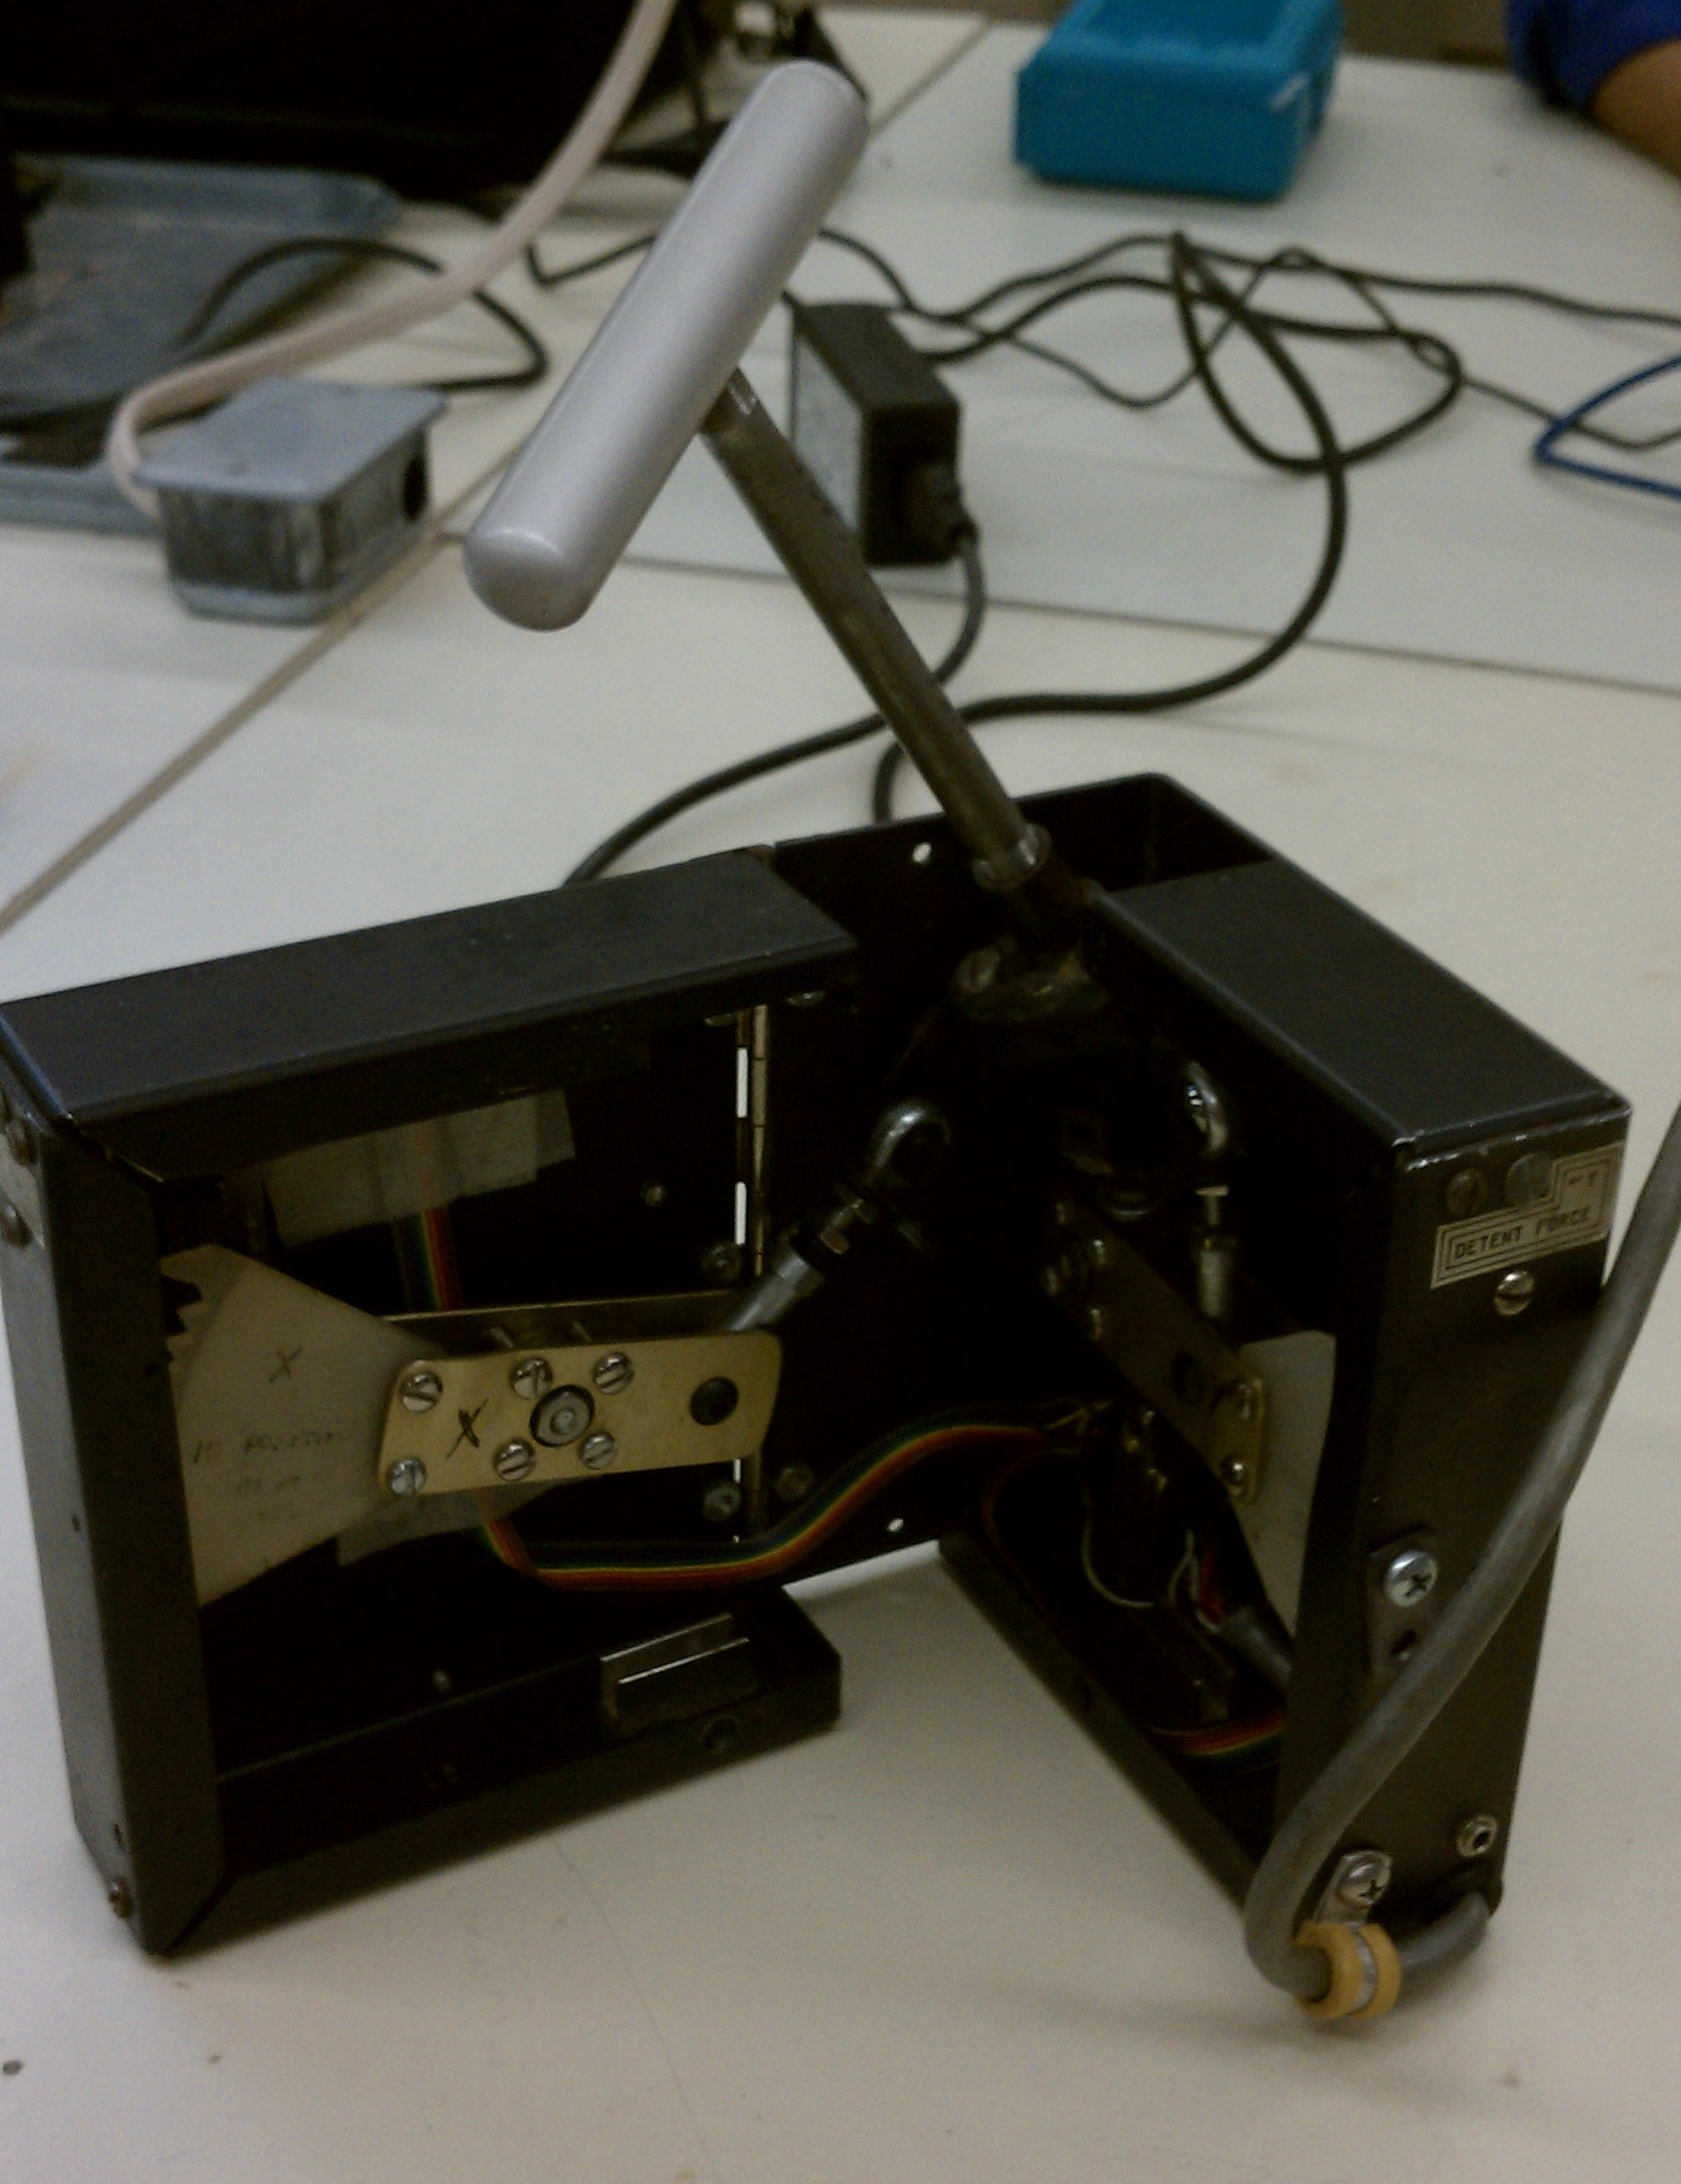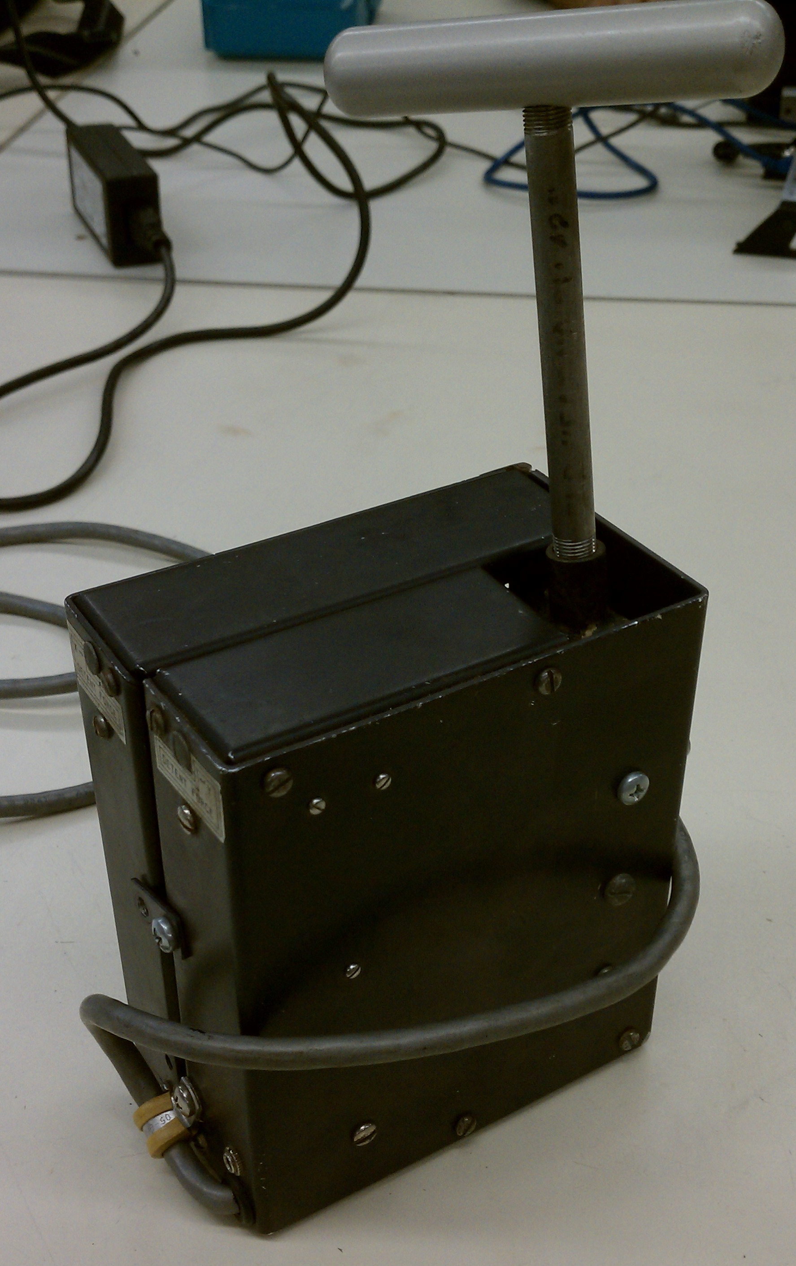
The current model of mechanically detented joystick

In the current joystick model, there is a plastic fan-shaped piece for each axis (x or y) with a set number of teeth. The number of teeth on each fan is what determines the number of detent positions available to users. If the number of detents is to be changed, new fans with a different number of teeth must be installed into the joystick manually.

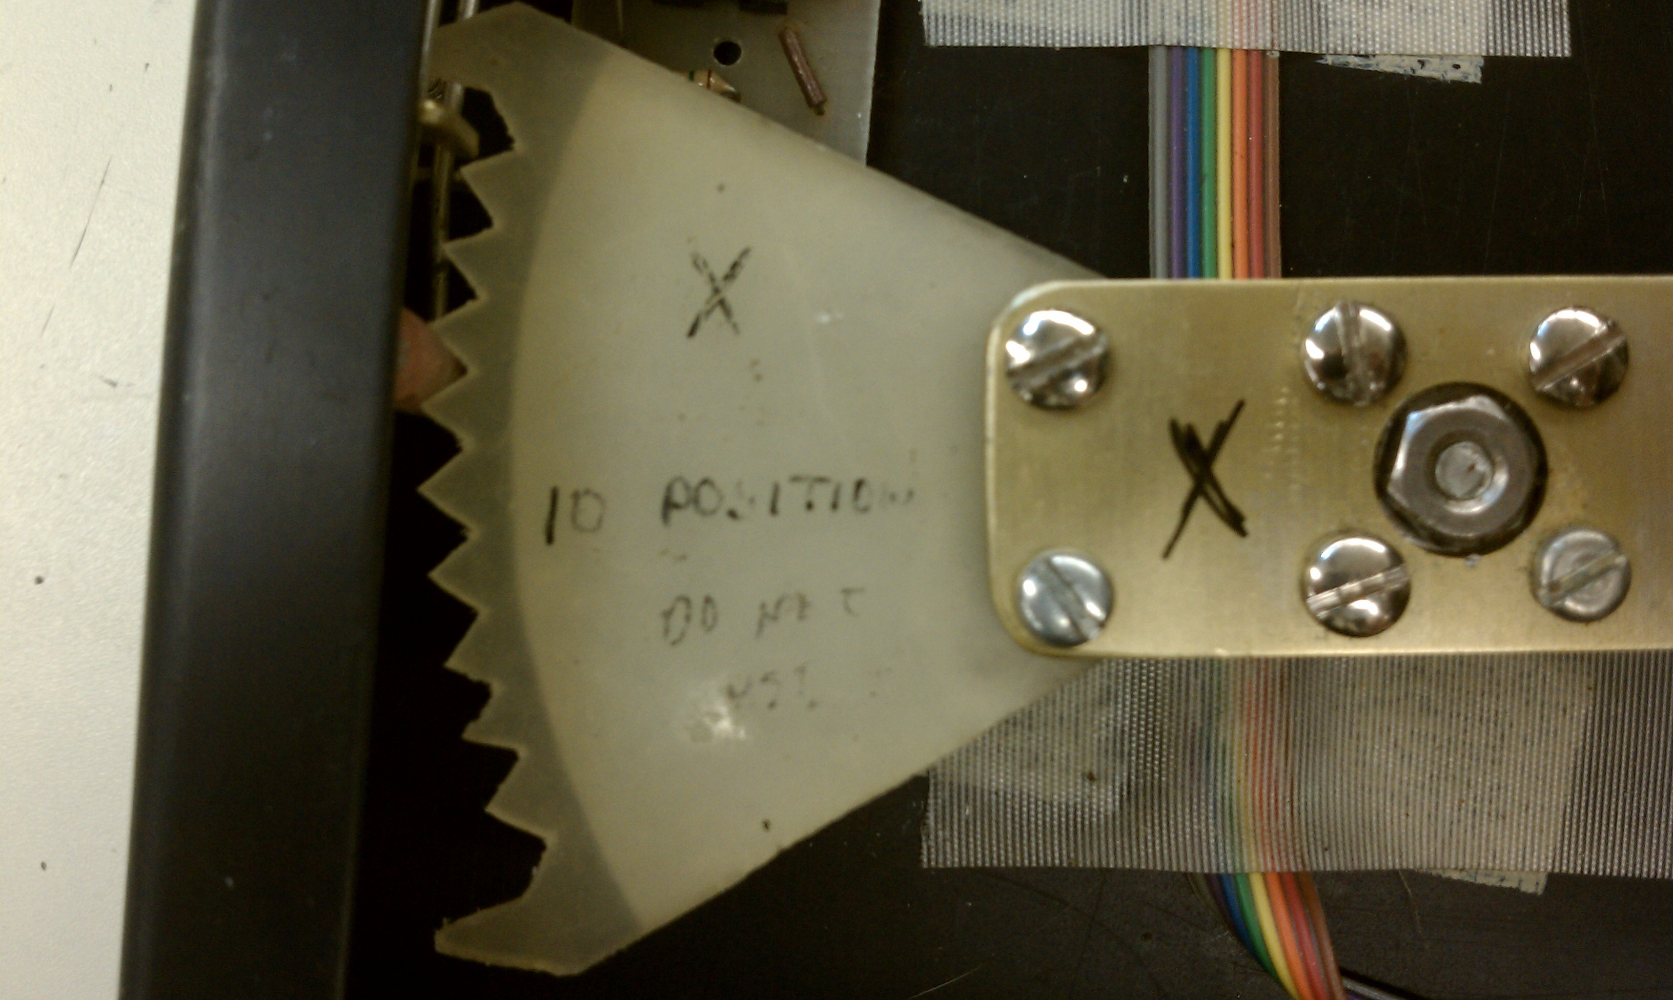
The plastic grooved fans currently control detenting.

The teeth on the fans interface with a rubber stopper. This stopper fits snugly into the grooves between each fan tooth. Connected to each stopper is a spring mechanism that applies a force to hold it in place. In order to move the handle, enough force must be applied to counter the spring tension and displace the stopper enough to move to the next groove. As the joystick handle is moved along either axis, the corresponding fan shifts to the next position and is set in place by the rubber stopper. The current method of adjustment is to tighten or loosen a screw on the joystick housing.

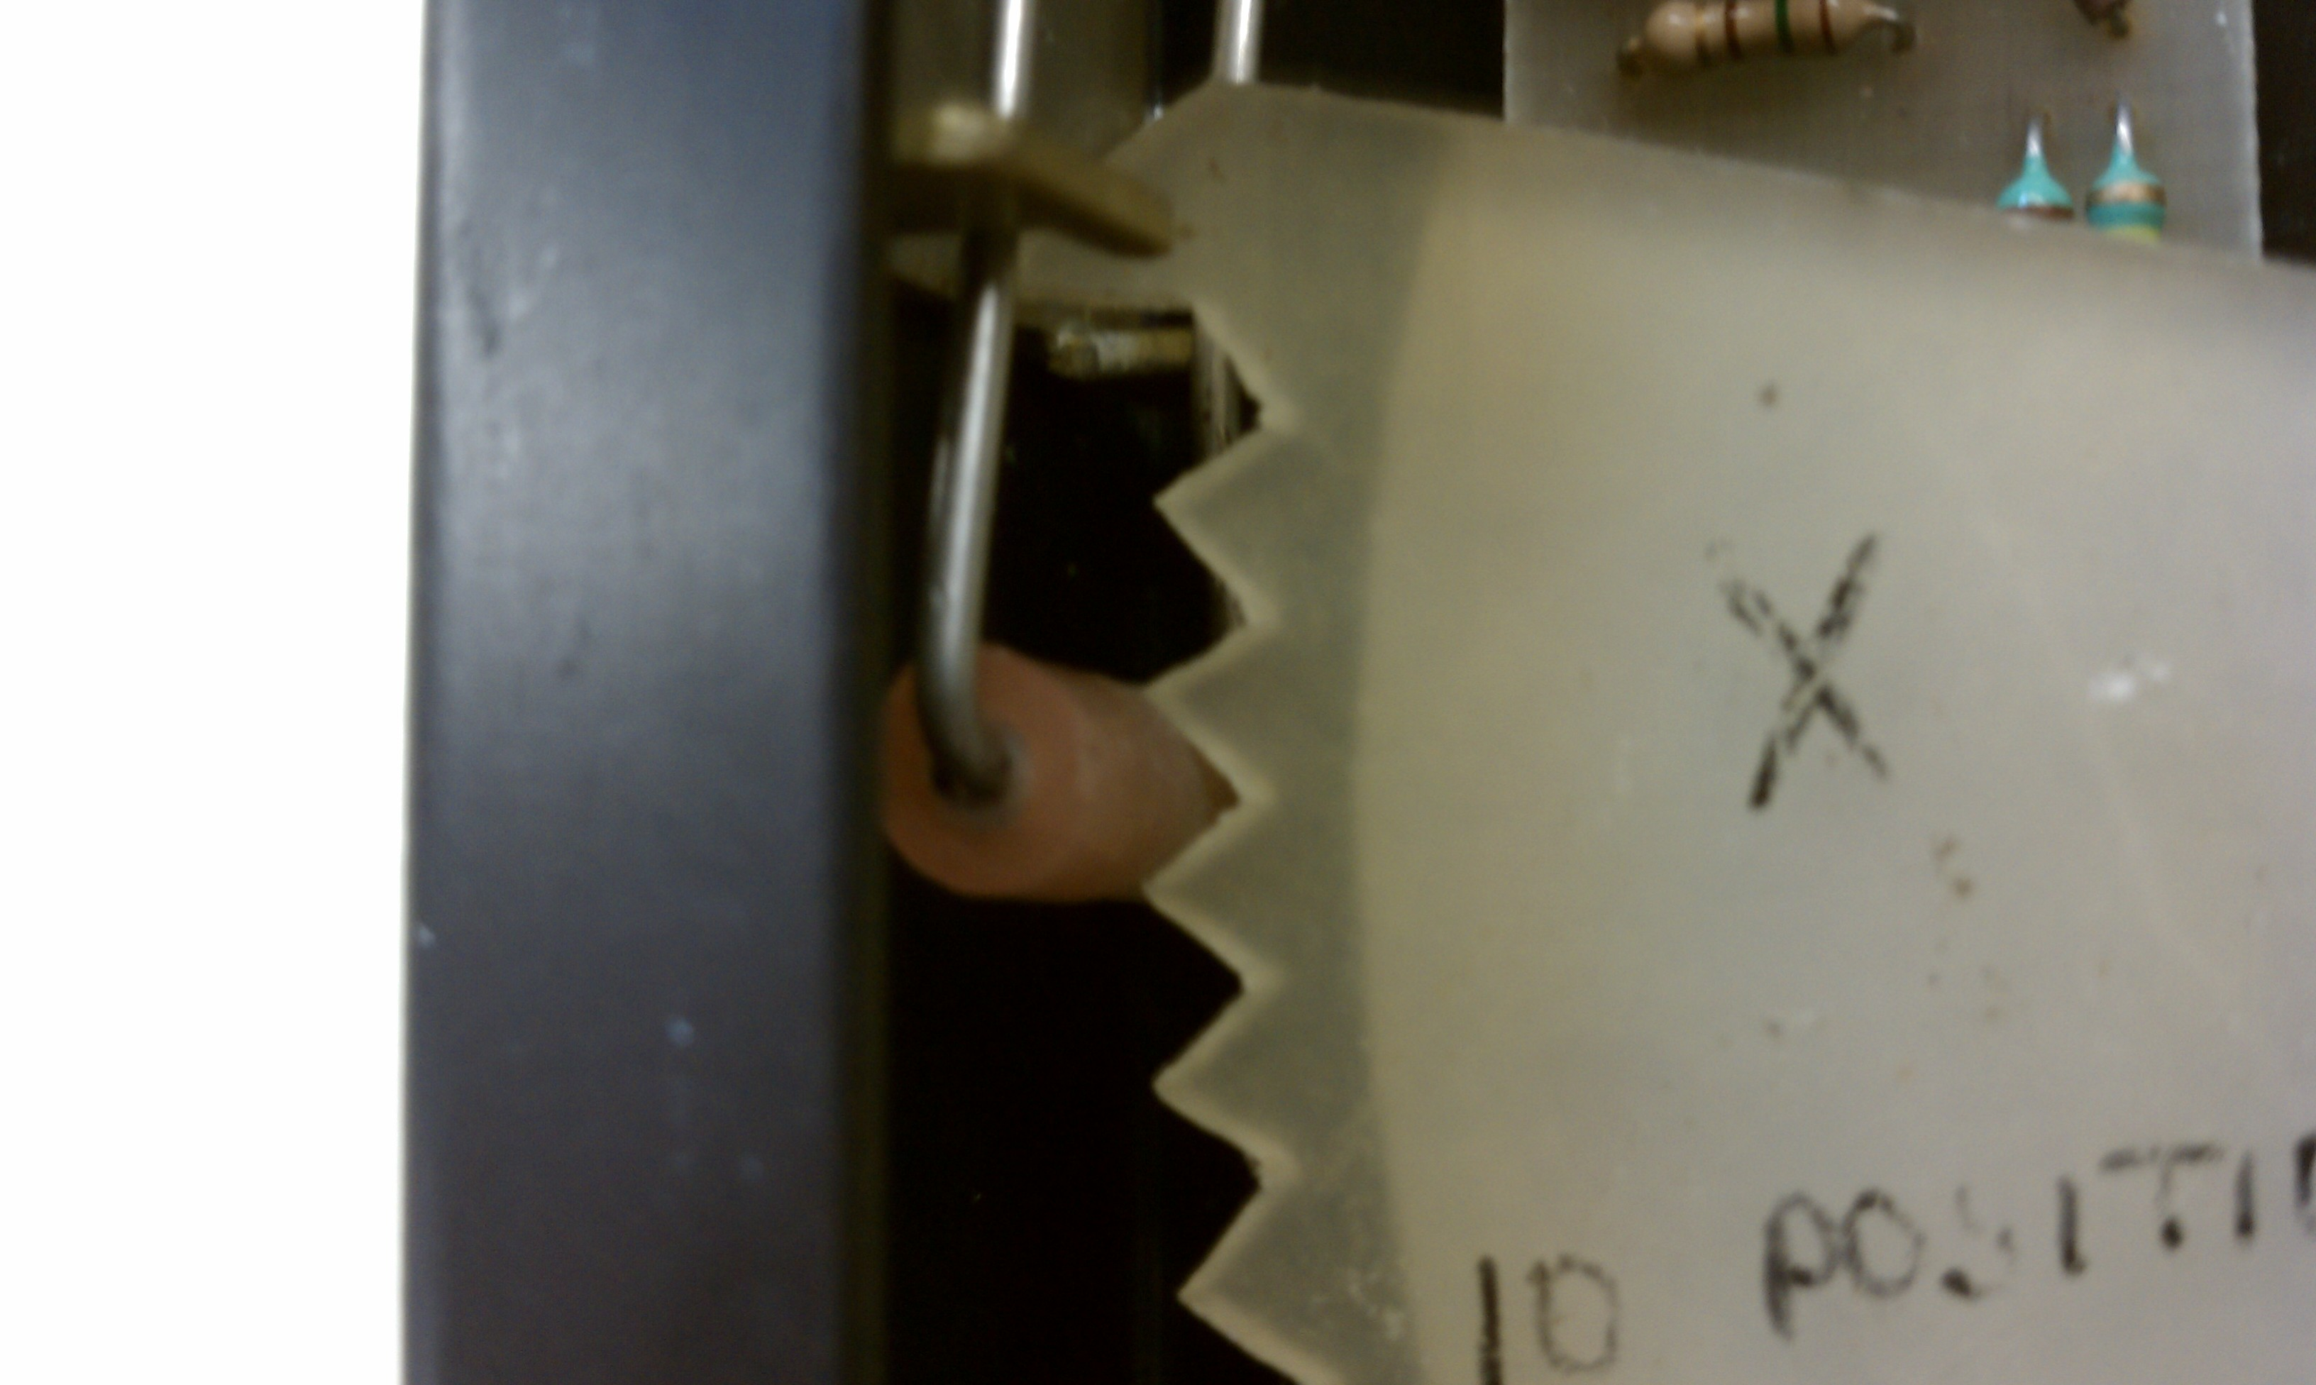
The rubber stopper is seen on the left. The tension on this stopper is controlled using a screw on the joystick housing.

In order to transmit the position of the joystick to a computer, there are still some necessary electrical components. The transmission method currently used involves a simple optic sensor circuit and a microcontroller. On the back of each fan, there is a pattern of reflective and non-reflective surfaces, as seen in the picture below. This pattern follows a traditional gray code pattern with four transmission bits, where moving from one position to either adjacent position will only alter the output by one bit of binary code. Facing the back surface of the fans are four infrared beams, and four optic sensors. If a beam hits a reflective surface, it returns the signal to the optic sensor, triggering a high output bit to the microcontroller. If it hits a non-reflective surface, the optic sensor receives no light, and a low output bit is triggered. The combination of the four sensor outputs on each axis generates a unique position code that the computer can interpret as the position of the joystick.

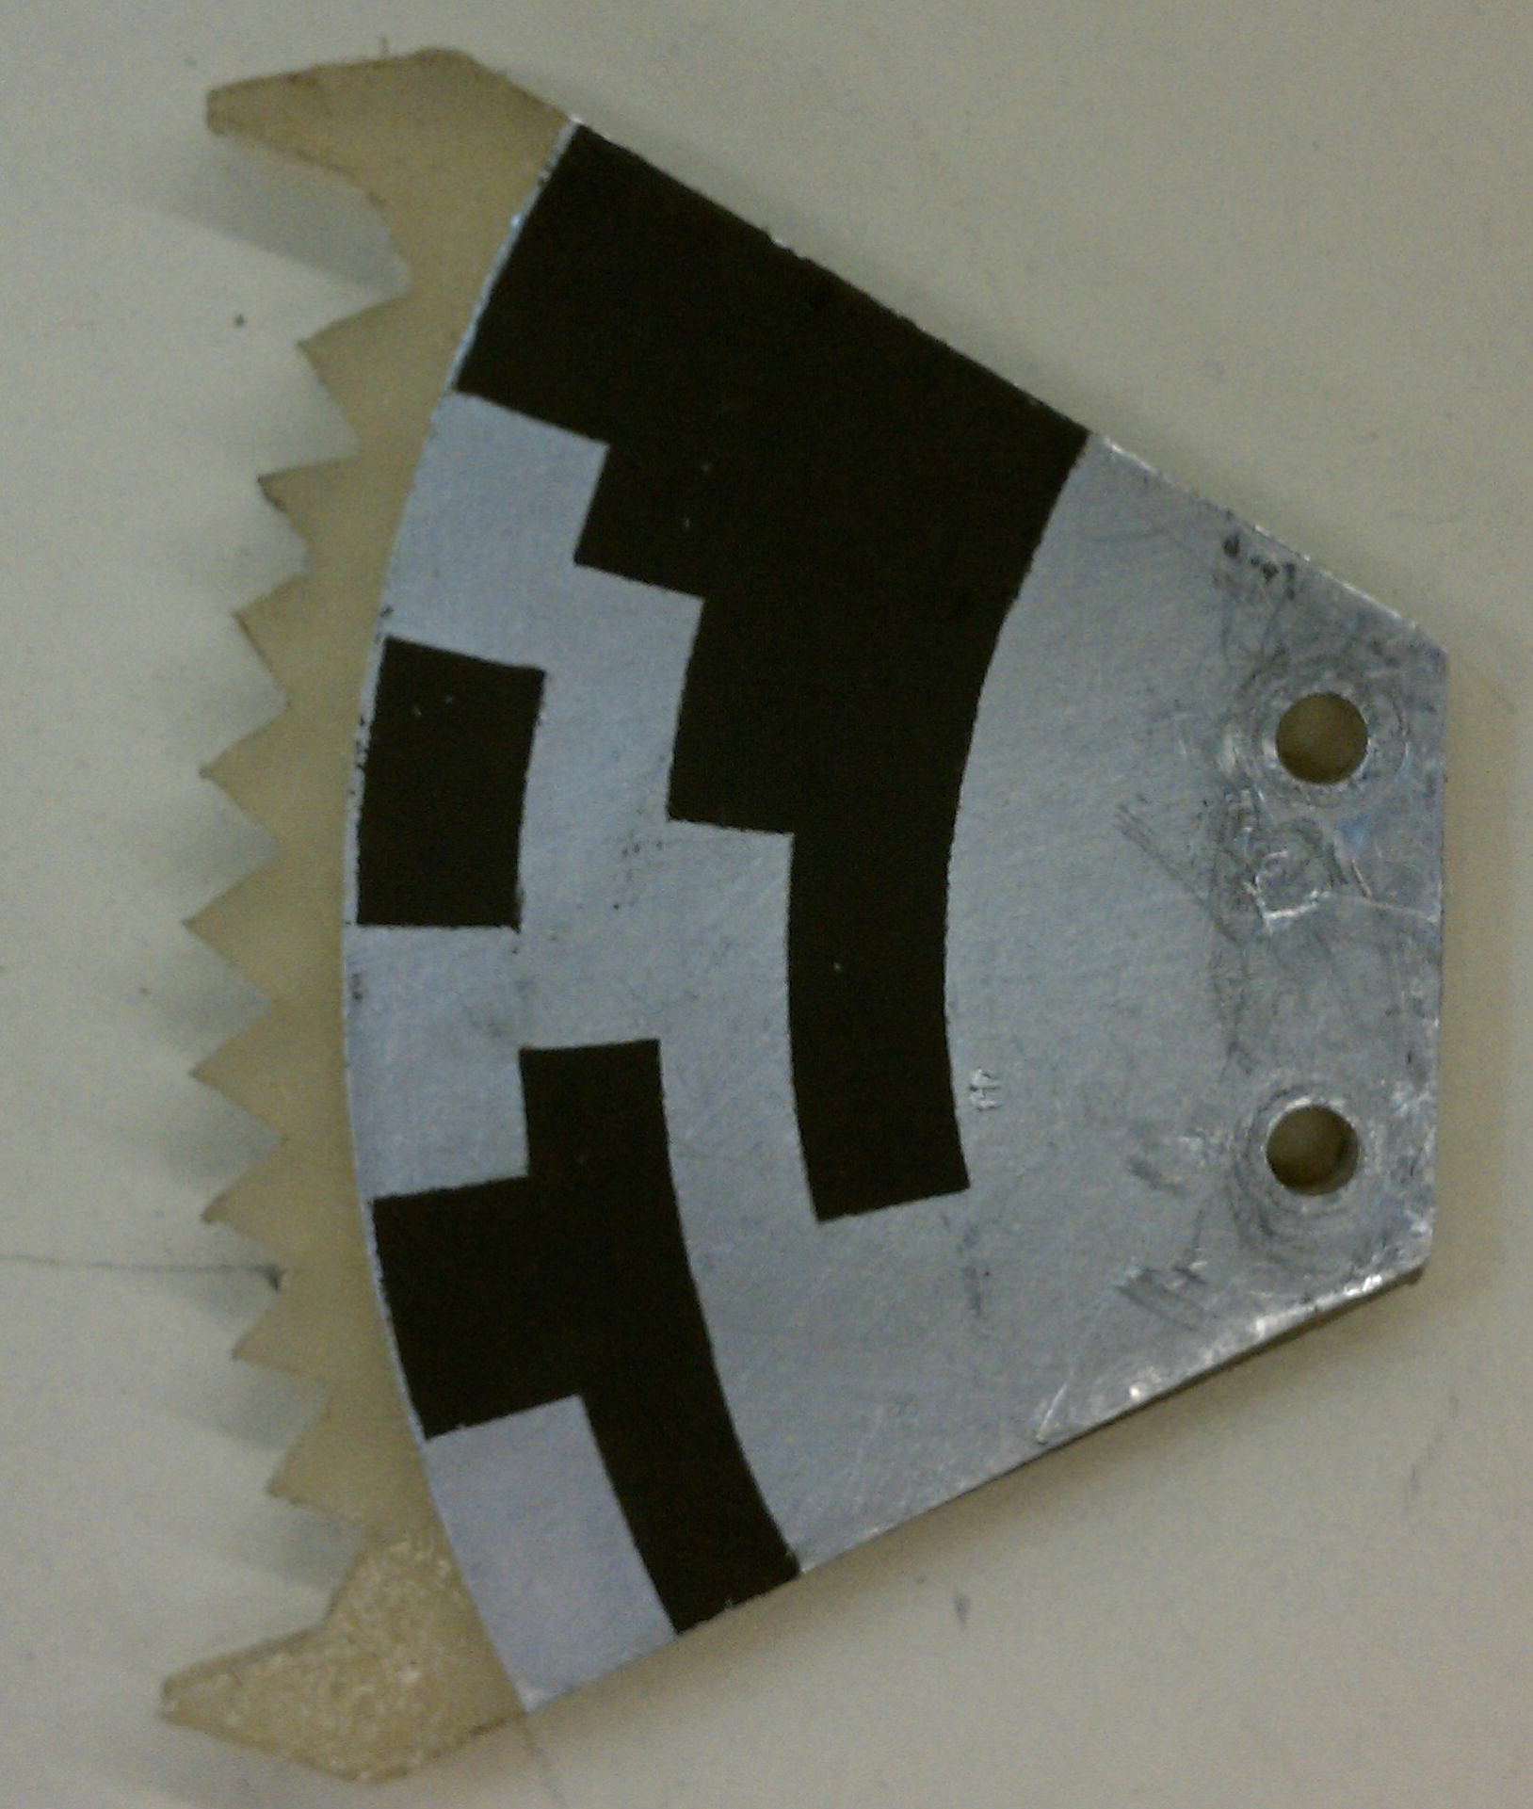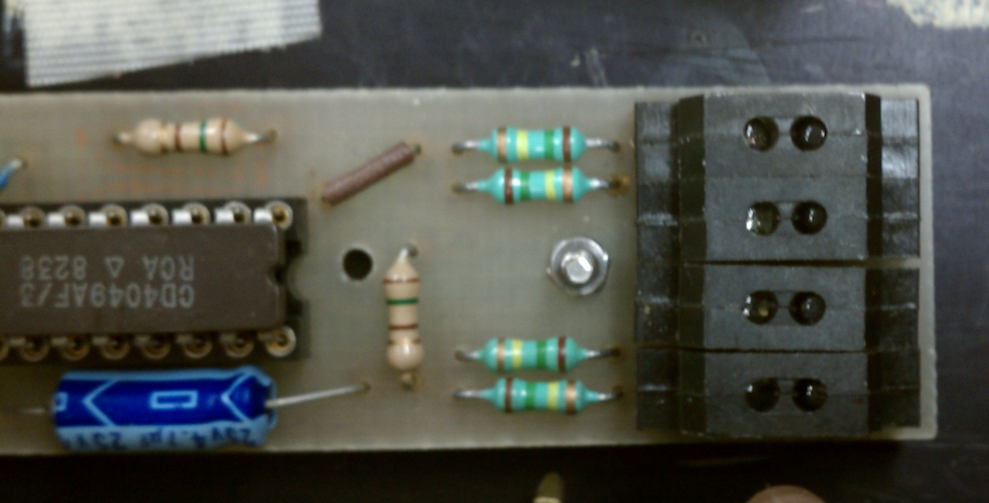
The reflective gray code on the back of a fan is shown on the left. The optic sensor circuit is on the right.

It can be seen that the current joystick technology relies on purely mechanical components to establish detent positions. In order to alter the number of positions or the force required to change positions, physical adjustments must be made. These are adjustments that generally someone with CP would be unable to accomplish on their own. These operations can also prove tedious for a living assistant who may not be familiar with the technology. It is therefore essential for a new design that simplifies the customization of the joystick and reduces the effort of communication.

Design Specifications

After examining the drawbacks of the current joystick model, the design specifications of the new joystick model were determined. This was done in correspondence with Mr. Stephen Blosser of Michigan State University’s Resource Center for Persons with Disabilities (RCPD). He has extensive experience working with Branden, as well as other people living with CP. He provided the insight necessary to create a design catering to the specific needs of Branden, with the flexibility to also work for other CP cases. The main objectives of the new joystick model were as follows:

- Software-selectable number of detents
- Software-selectable detent force
- USB connectivity with PC or Mac

In order to implement these design specifications, several new components had to be introduced into the joystick.

Design Approach: Component Overview

Linear Actuators
The first key component to the new joystick design is two linear actuators, one for each axis of the joystick. A single linear actuator is shown in the picture below. At the base of the actuator, there is a small dc motor. This motor controls the extension distance of the arm based on the voltage input received by the wire leads at the base of the actuator. Linear actuators serve as the basis of the detenting mechanism in the new joystick design, replacing the previous method of notched fans. Using a control program, which will be detailed later, the actuators can be operated in a manner simulating physical detents. The number of simulated detents is then adjustable through a simple software interface. This allowed the first design specification to be met.
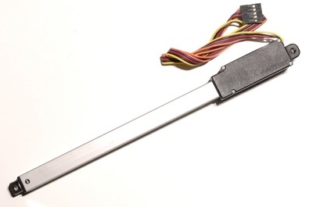
A standard linear actuator is seen above. Voltage applied to the DC motor leads determine arm extension.

Benefits of these linear actuators include relatively low cost, low power consumption, small package size, and ease of use. Another key benefit of the linear actuators is analog position sensing. Even when motion is allowed in a manner simulating mechanical detents, the exact position can be tracked in between detents. This was a key feature required to implement mouse functionality of the joystick. More specific details regarding the actuator parameters and additional circuitry will be discussed in Chapter 3.

Force-sensing Resistors

The next key component in this new joystick design is four force-sensing resistors (FSRs), one each for the positive and negative directions on the x- and y-axes. A typical FSR is composed of a conductive polymer layer that is between two layers of thin plastic insulation. Conductive leads extend from the polymer pad outwards where they can be integrated into a circuit. Under stress-free conditions, the resistance measured between the leads is considerably high. As force is applied to the polymer pad, the material becomes more compressed and the conductive particles within become more closely packed. This, in turn, reduces the resistance between the leads.

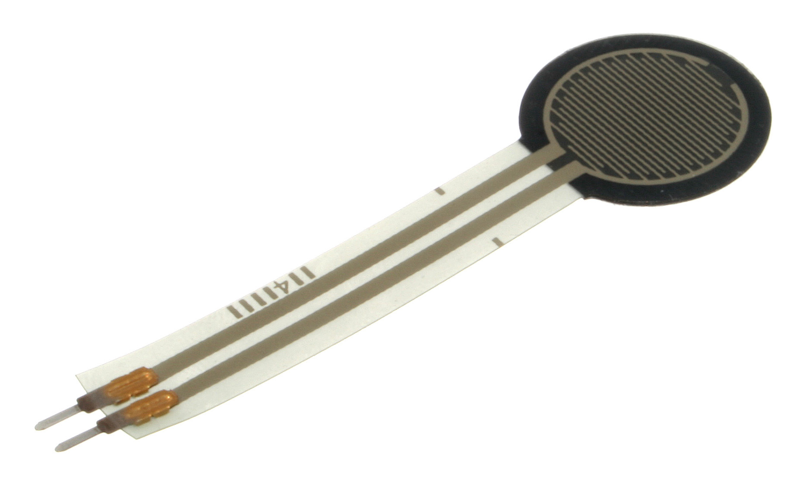
A standard FSR is shown above. The black portion is the resistive pad, which will change based on force input.

By including these FSRs into a simple voltage divider circuit, a voltage reading can be taken that corresponds to the amount of force applied to the resistor. Using software, a designated force threshold can be set for the FSRs. Under this threshold, no motion will be allowed on the joystick; however, if the threshold is met, motion will be triggered in a direction corresponding to the force input. The ability to set the force threshold through a software interface allows the second design specification to be met. FSRs are low cost, easily manufactured and mounted, and durable. These factors, along with the simple control circuit, made FSRs an ideal force sensing solution for this design. Further implementation details will be discussed in Chapter 3.

Arduino Leonardo

With the added electromechanical components, a new method of control needed to be introduced into the joystick to take on the increased responsibilities. This came in the form of an Arduino Leonardo microcontroller board. Some key features of this board include USB compatibility, 20 digital I/O pins, and 12 analog input channels. The Leonardo serves as the means of communication between the linear actuators and the FSRs. It also provides the computer interface necessary for extended joystick programming and a new graphic user interface (GUI), which the team has created from the ground up. The new GUI provides a functional and aesthetic way for the user to navigate and select keyboard commands with minimal effort.

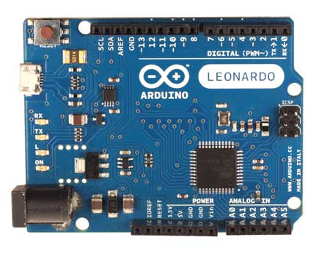
The Arduino Leonardo is seen here. It allows communication between the joystick components and extensive programming through a computer interface.

Like other boards made by Arduino, the Leonardo is low cost, easily customized, easy to program, and compatible with both Mac and Windows operating systems. It also has the benefit of being an open-source programming platform with the support of a strong user community. This plays an important role for future iterations of this joystick prototype. Others will have the ability to build upon the original code, promoting continuous improvement of the design. The Leonardo allowed the final design specification to be met. More software implementation details and functionality will be discussed in Chapter 3.

Selection Pedal

The last addition that had to be made to the new joystick is a compatible selection pedal. The system Branden currently uses has a button he can select with his hand separate from the joystick. The new joystick features a connected pedal, which the user can press either by foot or by hand based on personal preference. This is used as the primary selection method for the joystick once the user has navigated to a desired position.

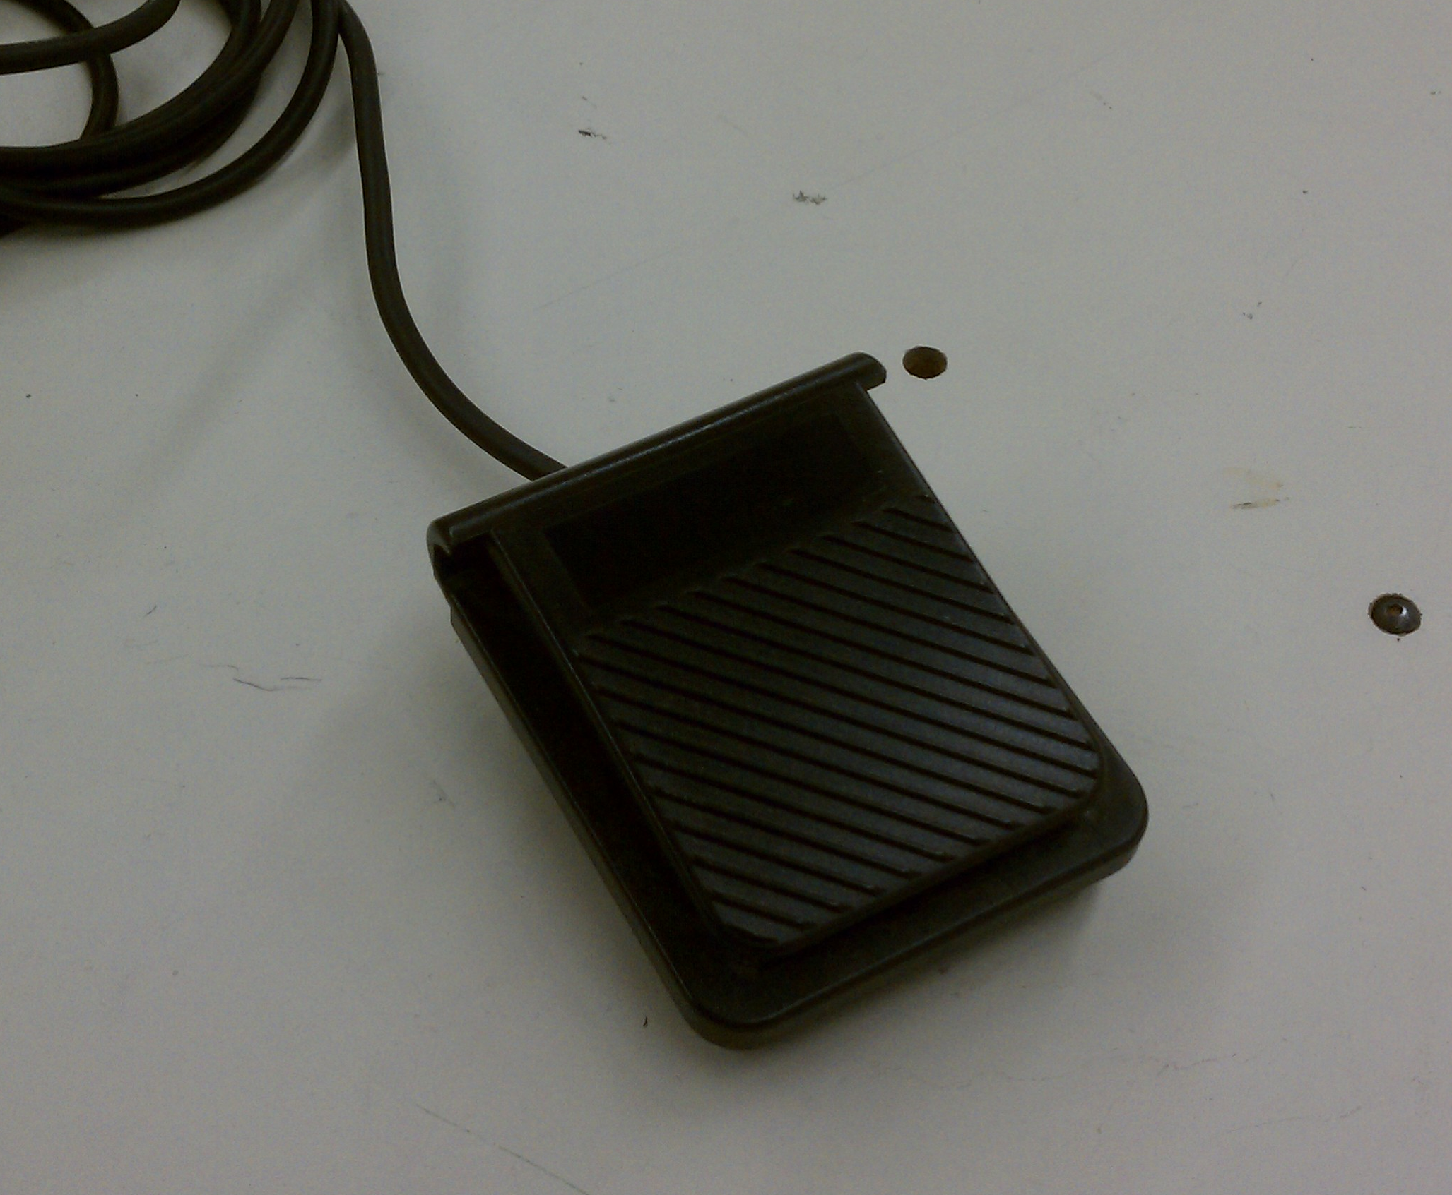

Impact of this Design

Throughout the design process, it is easy to get caught up in the “bells and whistles,” but most importantly, the end product must accomplish the core design objectives. In the case of this design, the ultimate goal was to minimize the effort it takes for someone with CP to communicate. Many can take this rather basic ability for granted, but for some it can be extremely difficult.
Currently, there are no detented joysticks on the market that display the level of customization seen in this design. Users will now have a way to quickly make adjustments to stability and range of motion. This is important for two reasons. First, with changing symptom levels over time, a user’s ability to work with a joystick can fluctuate, and fine-tuning is necessary to optimize the communication process. Second, this allows a more universal model of joystick that can be marketed to people with varying severity of symptoms. This will improve the repeatability and efficiency of production and drive down costs for those looking to purchase a detented joystick.
Developing this prototype using open-source programming methods also leaves the door open for great additions in the future. While it accomplishes the core design objectives and can function as is, this prototype also can serve as a building block for future designers to work from. This should promote the continuous improvement of a product that could potentially change the lives of many.

Chapter 2

Decomposition of Our Problem

The electromechanically detented joystick is an update to a exclusively mechanically detented joystick currently used today and developed by Mr. Stephen Blosser and Dr. John Eullenberg. The detented joystick’s main purpose is to support wanted inputs made by the user (typically a person with cerebral palsy) while refraining from unwanted or spastic inputs. In order to ensure a comprehensive and successful design, our design team investigated the current constraints of mechanically detented joystick and interviewed Mr. Blosser as with any voice of customer process. With the desired requirements recorded, our team proceeded to utilize the FAST Diagram seen below to organize the task, basic functions and secondary functions of our product. This diagram allowed for the decomposition of our problem into subcomponents that could be undertaken individually and begin cultivating a conceptual design.

FAST Diagram

Secondary Functions
Task
Basic Function

House of Quality and Critical Customer Requirements

With the basic and secondary functions well defined, our team dived further into developing a product concept that would achieve the requirements specified by Mr. Blosser. Our goal in concept design was to create an experience for the user that would benefit one (in our case, Branden) but have the customizability to support many others with cerebral palsy or similar symptoms. Placing these requirements in our House of Quality diagram, the team determined the critical customer requirements based on rank of importance, time constraints, monetary budget and viability. The components crucial to our success are shown below using the critical customer requirement approach.

Critical Customer Requirements Table
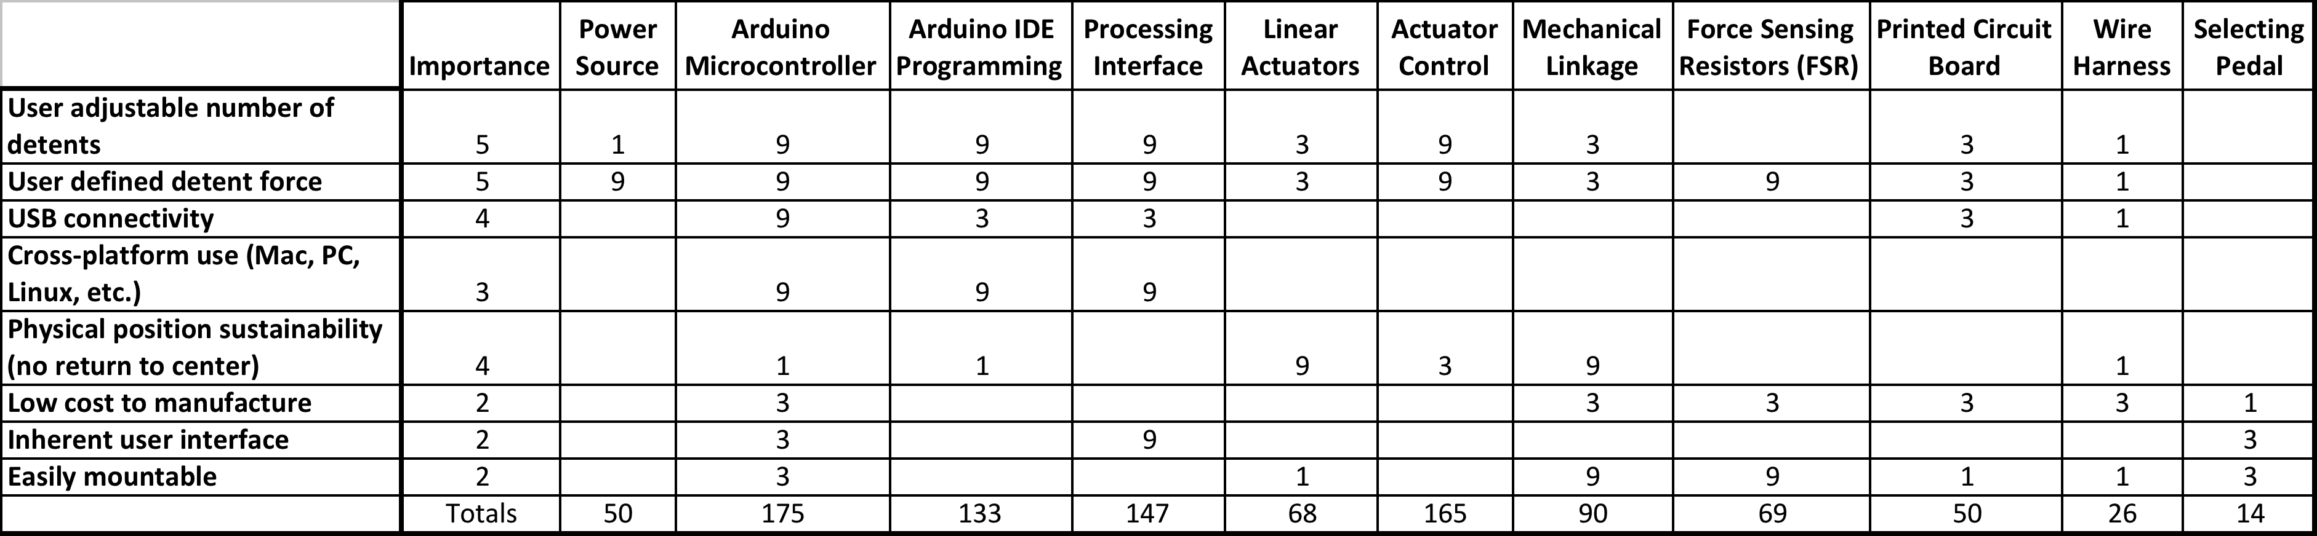

As stated previously in Chapter 1, our approach combines the concept of a detenting joystick with new and customizable technologies. Using components such as the Arduino platform and linear actuators, we can achieve user adjustable detents with an inherent user interface across many different computing platforms.

Budget

With a budget of $500 provided by Michigan State University’s Electrical and Computer Engineering department, our initial estimate accounted for many of the components used in the final design. The initial budget below, utilized 100% of the allotted $500.

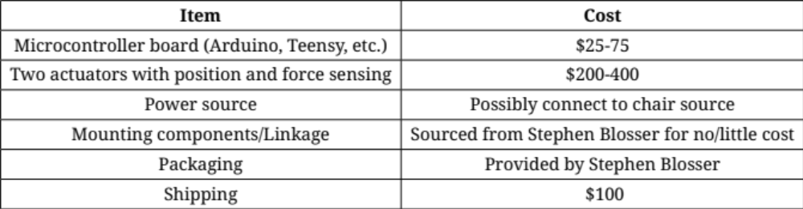

The final budget (see Chapter 5) was under the initial estimate and thus we were successful in staying below the initial allotment.

Project Timetable

Due to the design constraints previously discussed, development of this product was done in four design phases.
- Phase One is researching State of the Art, as there is a mechanically inclined product currently being used in market.
- Phase Two will consist of applying electromechanical devices to accomplish our goals and meet or exceed specifications.
- Phase Three will consist of prototype development. Prototype packaging, hardware and software will take the majority of our schedule (about 60% of timeline).
- Phase Four involves prototype testing and final product development. This four-phase plan will supply ample time and ensure a superior product in terms of usability, quality and cost.
Our completed GANTT chart can be found in Appendix 3-B and depicts our design team’s critical path stated above.

Chapter 3

Hardware Specifications: Linear Actuators

The linear actuators are what essentially control the motion of the joystick. This needed to be done in a manner simulating the detented motion of the previous joystick. In order to achieve this motion, the team determined the optimal technical specifications required of the linear actuators. The specifications are as follows:
- Stroke length: 50 mm
- Voltage: 12 V
- Orientation: Vertical
- Load: 40 N
- Precision: .1 mm
- Speed: 40 mm/s under no load conditions
The actuators chosen to meet these specifications were the Firgelli L16 series linear actuators. They featured a stroke of 50mm, 12 V operating voltage, and forces exceeding 50 N. The speed available was around 32 mm/s, which was lower than the initial specification, but was determined to still work for the design. These actuators also featured built-in position sensing and a small package size. These actuators were relatively low cost at $80.00/actuator. This was a key factor in determining to choose Firgelli due to the budget constraint.

Hardware Specifications: The H-Bridge Chip

H bridge chip is an essential component in our joystick design. It is an IC Chip used mainly for its controllability of actuator motor’s direction by changing the polarity of the voltage across it such that two actuators in x and y direction would move both forwards and backwards. Therefore, users would experience a joystick that is less directional limited and could be controlled through x- y direction at any point. The alternative is LAC Board, which comes with Actuator packing and will be discussed in the next section.
A simplified H bridge circuit is shown below. It mainly made up of 4 switches, either mechanical or solid state transistors (MOSFETs or BJTs). The following table summaries functionality of H bridge chips. In addition to changing polarity of the motor, H bridges can also act as a brake for a sudden stop of the motor and controlling the motor speed.

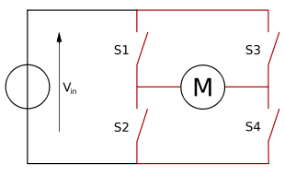

S1 S2 S3 S4 Functionality
1 0 0 1 motor biasing to the right
0 1 1 0 motor biasing to the left
1 0 1 0 motor brakes
0 1 0 1 motor brakes
0 0 0 0 free motion

The schematic:

L293DNE H bridge is made up 2 sets of pins on both sides of the chip with each pair in charge of one DC motor, enabling the chip to control 2 motors at once through a single chip. The chip provides bidirectional drive currents controlled through the 2 pairs of input pins and each pair is composed of 3 input pins: 1,2EN, 1A and 2A referring to the diagram below with 1Y, 2Y, 3Y, 4Y being the outputs that is connected to motor terminals, in our cases, actuator motor terminals. Vcc pins are connected to power source.

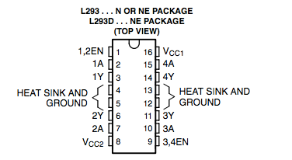

The functionality is summarized in the following table using the left pin set of the L293DNE diagram shown above.
Fuction Table

Enable Pin 1A 2A Functionailty
H H L turn clockwise
H L H turn counterclockwise
H L L motor stop
H H H motor stop
L X X Off(high impediance)
Note: X: Has no effect

Design Specifications: The H-Bridge Chip

The particular H-bridge chip we are using is L293DNE by Texas Instruments with its design specifications:

Voltage range: 4.5 V to 36 V

Current output per channel: 600 mA

Maximum current per channel: 1.2A

High noise immunity

Thermal shutdown

From testing, the Firgelli L16-D actuators we are using requires at least 7.5V to operate as we expected mainly due to the desired moving speed of actuators which is associated with detenting, Actuators are powered through H-bridge power input and the 7.5V falls ideally among L293DNE H bridge voltage range. The resulting current of actuators is 500mA from experiments, which matches well with the current output of H-bridges as actuators are controlled through H bridge chip directly. Besides the power and current output satisfies what we desired ideally, H-bridge chip is also an ideal option for us due to its high noise and thermal immunity, eliminating many potential environmental factors since the actuators heats up slightly when operating for a while.

Hardware Specifications: Force-Sensing Resistors

Before settling on using force-sensing resistors (FSRs), the team explored more expensive options such as force transducers and strain gauges. These proved to be way outside of the $500.00 budget available, and though an extension was approved, the team was determined to find another route. Originally, the team was hesitant to use FSRs due to their relatively low precision and low complexity, but with the help of the team’s sponsor, Mr. Blosser, the team was able to find an intuitive way to mount FSRs into the joystick housing and take advantage of their force sensitivity. Characteristics that were desired in the FSRs were linear force response, small size, and durability. Mr. Blosser ended up having some on hand that fulfilled the desired specifications. The interface of the FSRs and linear actuators with the joystick housing will be discussed in the next section.

Hardware Specifications: Arduino Microcontroller Board

Working at the heart of the team’s joystick is an Arduino microcontroller board. Arduino is an open-source electronics prototyping platform designed for artists, designers or other persons interested in created an interactive environment with a microcontroller. As was stated earlier, the team settled on the Arduino Leonardo prototyping board. Several key features which helped in completing the project objectives included:
- A USB interface
- Low power
- Low cost
- Future upgrade potential
- Small package size
- Built-in libraries

Probably the most important feature of the Leonardo was the USB interface, which was one of the team's design objectives. This interface is compatible with both Mac and PC. It allows the Leonardo to run entirely off of a USB 2.0 port, and also can provide instant recognition by the computer that the connected device will function as a mouse or keyboard. The joystick will work immediately as soon as an automated driver initialization takes place on the machine.

One limitation was that the Arduino can only have 50mA of maximum current flow through any given pin; however, this was acceptable due to the other lower power components utilized throughout the design. The Arduino also had the capability of allowing up to 12V of additional voltage through an external DC source. This was taken advantage of in order to provide the actuators with the additional voltage necessary to operate at ideal speeds.

The cost of an Arduino board typically runs around $25.00. The team was able to have the Leonardo shipped for $27.19 in total. The low cost of an Arduino board was a valuable asset in the case of a board failure, especially when operating on a small budget as the team was. The low cost also allows easy upgrades in the feature. Other board models with different features could be tried without a large hit to the budget.
Another benefit of the Arduino Leonardo is the small package size. This allows for the team to install the Leonardo in a small box aside the joystick. The dimensions of the Leonardo are 2.7 in x 1.1 in (66.0 mm x 27.9 mm). In effort to keep package size down the use of shields for the Arduino can consolidate hardware while expanding the functionality. The team fabricated a PCB, which includes all of our circuits, on top of the Arduino. This design allows for shorter leads, smaller margin of error, and a cleaner and condensed final product.

The final key benefit of the Arduino platform is the easy access of additional libraries. These can provide the user with added functionality through a quick command using Arduino's IDE. These libraries are often found free of cost through the extensive Arduino support community and can greatly simplify the programming process. One library important to this design was the Servo library, which provides the user with control over a dc motor. This could be applied to the two linear actuators.
Along with the features listed above, the Leonardo provided the proper number of inputs and outputs and processing power required to implement the design plan:
- 14 Digital I/O pins (7 required)
- 12 Analog inputs (6 required)
- USB Interface 32u4
- 32kB Flash Memory for saving the program into memory

Hardware Implementation: Mounting Linear Actuators and FSRs

Inside of the joystick casing, the two linear actuators are mounted vertically as shown below. The extending arm is mounted to the joystick handle linkage in a way that each actuator has control over a single axis of motion.

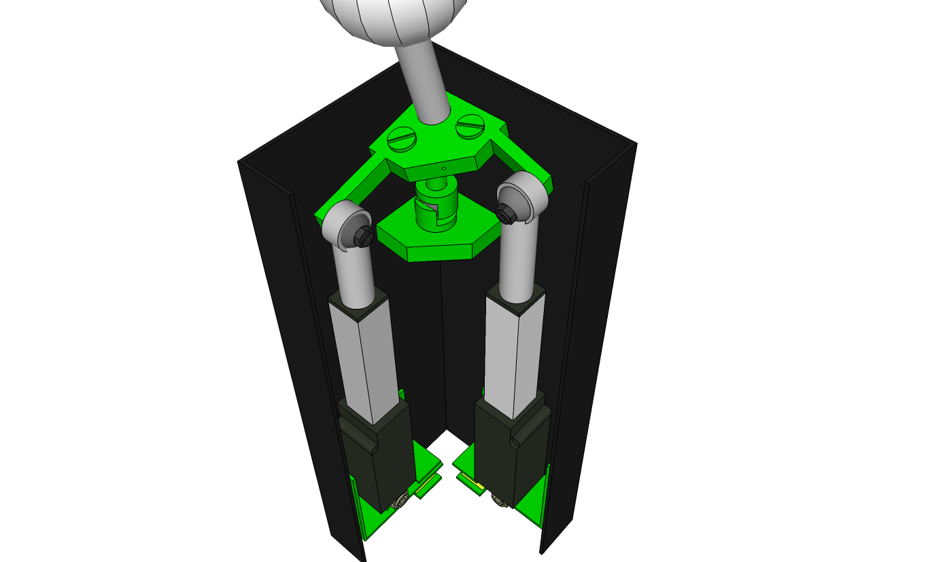

The base of each actuator is mounted to a flexible piece of metal. One end of this metal piece reaches out between two other metal brackets, which are attached to the joystick housing. The FSRs are mounted on the inside faces of these two metal brackets. If force is applied along one axis of the joystick, this motion will transfer to the corresponding actuator. This will either put downward pressure on the shaft of the actuator or pull it upwards, based on the direction of the initial force. As the actuator body moves either upwards or downwards, the metal piece mounted at the bottom will press either against the top or the bottom FSR. The orientation of this system is shown in the diagram below.

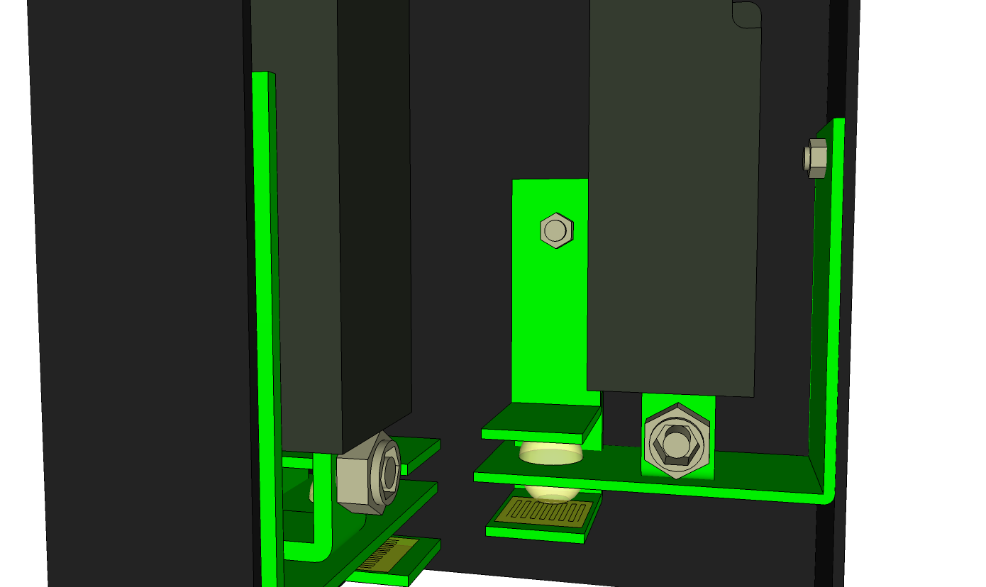

Hardware Implementation: Linking Linear Actuators to Microcontroller

Initially, the team experimented with some included control boards (LAC boards), which were also made by Firgelli for use with their linear actuators. The LAC boards were good for getting familiar with the actuators and allowed quick testing; however, the team eventually decided to integrate the actuators using another method. This method was by using an H-bridge chip that would interface with the Arduino microcontroller. This chip was acquired as a free sample from Texas Instruments and allowed precise control over the linear actuators using the Arduino Leonardo. The advantages of discarding the control board and using the H-bridge are summarized below:
- Cleaner integration with code:
- Lower level
- Use of basic Arduino function calls
- Integration with position control
- Lower power consumption
- Lower response time
- Higher resolution
- Noise reduction

Hardware Implementation: Linking FSRs to Microcontroller

In order to interface the FSRs with the Arduino Leonardo, all that was needed was a simple voltage divider circuit. The Arduino’s analog inputs were used to read a voltage over a pull-down resistor in series with each FSR. This voltage changes based on the fact that when force is applied to the FSR, the resistance decreases. This, in turn, increases the voltage on the pull-down resistor. If a specific voltage level is set which corresponds to a desired threshold force, it can be used as a signal to the microcontroller to allow linear actuator movement when force has been applied to the joystick handle in a specific direction.

Some other circuits were experimented with that potentially provided better FSR linearity for high input forces, but it was determined that the simple pull-down resistor approach would suffice for the level of forces that needed to be recognized.

Hardware Implementation: Selection Pedal
There was no extensive research necessary for the selection pedal. All that was needed was a simple button switch that could signal that a desired position had been reached. A member of the team brought in a keyboard pedal that was already in their possession that worked for the design. The selection pedal had a rather simple implementation process. One input was placed on a digital pin of the Arduino while the other end was wired to the 3.3V terminal. The pedal is used as a single left click, which can select anything on the screen including keys selected on the GUI keyboard.

Hardware Implementation: Arduino Leonardo
As was stated earlier, the Arduino is necessary to relay signals between all the crucial components of the joystick. Seen below is a breakdown of the analog and digital pin usage on the Arduino:
Analog:
- A0 – Potentiometer feedback on Actuator X
- A1 – Potentiometer feedback on Actuator Y
- A2 – FSR +X input
- A3 – FSR –X input
- A4 – FSR +Y input
- A5 – FSR –Y input
Digital: (All connected to TI L293D H Bridge)
- D2 – Enable for Actuator X
- D3 – Actuator +Y
- D5 – Actuator +X
- D8 – Foot pedal
- D10 – Actuator –Y
- D11 – Actuator –X
- D12 – Enable for Actuator Y

Software Development

The software architecture supporting the project, consists of two main branches :
- Code that runs on the hardware, which is the detented joystick.
- Software that the end-user will use in the form of a Graphical User Interface(GUI).

Code for the Arduino initially started after wiring one of the linear actuators to the microcontroller with the use of an LAC board, as discussed previously. This method allowed for easy movement of the actuator through servo library commands.
Initial coding of the joystick allowed for time delay based detenting. Detenting was not very accurate and an overcompensation of force would reposition the handle for the preceding movement. This would skew the movement between the joystick handle and the mouse movement on the screen. To compensate, mouse movement implementation consisted of speed based positioning. Faster strokes accounted for greater mouse movement on screen. This method did not provide constant response with for joystick and cursor movement.

Using the LAC board caused many issues that programming could not reach around. After the team introduced the H-bridge to the Arduino, issues of latency and control were dismissed. The H-bridge provided exact control over the desired position for the Arduino. Very little response time is added to the transmission of the signal.
While other issues mentioned disappeared at the time, new issues replaced them. Communication support with the code was very weak now due to the H-bridge necessitating completely different control functions. The code structure converting from the LAC to the H-bridge was preserved, but some functions had to be replaced. Support for actuator control with the LAC required one input line with analog values while the H-bridge requires two input lines with digital values.

This conversion did not take much effort to implement, but realizations of functions changed as positioning requires a different logic flow. Previous position relied on comparing analog values with the position feedback directly and setting position by use of a single function. The H-bridge required a comparison to a value that is lesser or equal to the positioning read from the actuators. This implementation required more lines of code for working with two inputs as well as passive control since the code must wait for this value to be fed back to the Arduino and signal must be sent to the H-bridge again to stop movement when a desired position is reached. This system does not always reach the exact desired position, hence the programming direction taken.

As a result of inaccurate placement, emphasis is pushed on feedback control parameters. Through the use of feedback control, accuracy is seen to increase but at a cost of time delay. Many delay parameters are introduced to find the sweet spot of operation for the user.

Low level operations

For controlling the joystick, writes are handled by two separate functions, one for each actuator. The command used for controlling the movement consists of inbuilt Arduino function digitalWrite(). This function sends a corresponding opposite high or low value to both of the pins connected to the H-bridge.
After a movement that is less than or greater to the current position, depending on if the current position is greater than or less than the calculated position, a digital write of both pins to low is necessary to stop the actuators from moving and keep the current position.

Both actuators have two inputs from the h bridge leading into the Arduino. The pin movement is handled based on this table:

Enable (D2)  OR (D12) | Pin (D11)  OR (D5) | Pin (D3)  OR (D10) | Function
HIGH | LOW | HIGH | Turn clockwise
HIGH | HIGH | LOW | Turn anti-clockwise
HIGH | LOW | LOW | Stop
HIGH | HIGH | HIGH | Stop
LOW | Don't Care | Don't Care | Stop

Given the nature of error correcting built into the code, the possibility of entering a state were all wires enable, h bridge enable and digital actuator –X & +X (or actuator –Y & +Y) are high are low. Entering this state causes the h bridge to shut off to protect itself from damage imposed to short circuiting the MOSFETs.
The FSRs connected to the Arduino are read from a range of 0 to 672. From this range force threshold values are made and set into the code. The values are compared to threshold values which are not triggered until the threshold is met or exceeded.

When selecting with the foot pedal the Arduino registers either a high or a low value on the digital pin. With the nature of this low level value the Arduino code looks for the binary change and issues either a mouse click or release.

The code used for mouse click takes two forms. One is for a single mouse click and holds until the user releases the pedal while the other performs a click and holds the click for a user programmable delay and automatically releases it. Utilizing both forms of click response the pedal has the ability for click and hold as well as single click depending on the standard use of the pedal. If the user prefers, either of the click methods and be substituted based on specified click mode talked about in more detail later.

Design of Arduino code

Starting with the initialize function of the program values for actuator minimum and maximum stroke lengths are defined. These values are defined in measurements from 0 to 672, though the useable stroke length is much shorter ranging around 150 to 425 depending on the actuator. Both actuators have different calibration values that result in similar performance—same amount of movement.
Many different variables are assigned to analog and digital pins, equations are produced based off of assigned pins that are used for the joystick. These values include:
- Feedback features
- Initial positioning of the joystick
- Number of detent calculation
- Force thresholds
- Pedal count/delay values
- Boolean statements:
- Axis orientation
- Serial input flags
- Keyboard/mouse toggles
- Joystick center position initialization
- Click parameters:
- Long press
- Double click/multiple click delay time
- Mouse click features
In the setup function basic setup values are called:
- Serial initialization
- Mouse/keyboard initialization
- Define
- Inputs
- Actuator Position sensing (Pins A0 & A1)
- Outputs
- Actuator controls (Pins D3, D5, D10, & D11)

The code designed for the joystick was built on several main ideas:
- Modularity
- Room for improvement
- Easy control by changing values at the start of the code

Body of code

The body of the loop checks for serial input and force threshold breaching. Once a serial command is sent to the Arduino runs through a statement check and compares it with recognized values. Instead of waiting for an entire serial input, which consists of ‘% *char* *number*’ the code will take ‘%’, ‘*char*’, and ‘*number*’ independently thus allowing for regular joystick operation as the code waits for serial input.

Serial input is sent from the keyboard component of this project. The keyboard sends three characters to the Arduino, which interprets the commands and scales code parameters. These changes will be saved in a text file and loaded every reset of the keyboard.

The serial input function incorporates error handling, such if an unrecognized value is sent through serial the serial command will be ignored completely until another ‘%’ value is received. Since serial input will be used sparingly such a short serial command can be permitted. Such a short command makes it easy to reprogram if desired to quickly change/toggle features on and off.

When re-assigning a variable through serial the Arduino code, upon a refreshing detenting size the code will reinitialize detenting, enable keyboard if mouse is disabled, or prevent binary values from being written any value two through nine.
After passing through the serial function, the code will wait for a force threshold registration across one of the four FSRs. If a force spike is detected, the next position movement for the actuator will be calculated and a function call will complete the movement. After, the mouse will move one unit direction on the screen.

The movement of the actuator is position based therefore if the user pushes too hard on the joystick it will go to its exact calculated position in 2-dimensional space. This will provide flexibility and prevent injury to the user or damage to the device.
If the joystick is on any of the four sides the code will enter a loop that can only be broken by detecting a movement in any other direction but one telling it to continue past the end of detent movement. In this loop the mouse will proceed to move across the screen. This allows for complete freedom on the computer greatly expanding the range of operations the joystick can handle.

With such expressed freedom the user is not constrained to a single window, instead navigation across a windowed user environment should be possible. This movement can be used for any number of applications. The inclusion of the foot pedal will expand user control even further.

The foot pedal is designed to function like a modern touchpad on a laptop. A registration of two clicks within a user modifiable time delay will result in a double click, exactly like what is found on a computer mouse. This can be used for many applications. If the user does not want the mouse to function in this manner any of the five provided pedal controls, explained later on are available for control through serial port re-declaration.

Here is pseudocode modeling for the routine followed by the Arduino.

LOOP
WHILE serial input check for serial input
READ serial input
IF valid serial input
SET specified parameter to new serial value
ELSE exit serial input check

IF joystick position is equal to maximum or minimum position prevent movement
IF force threshold value is met or exceeded
INITIALIZE new position value
INCREMENT position counter
WRITE actuator movement
WRITE cursor movement

IF pedal click present perform selected click routine
END of loop body

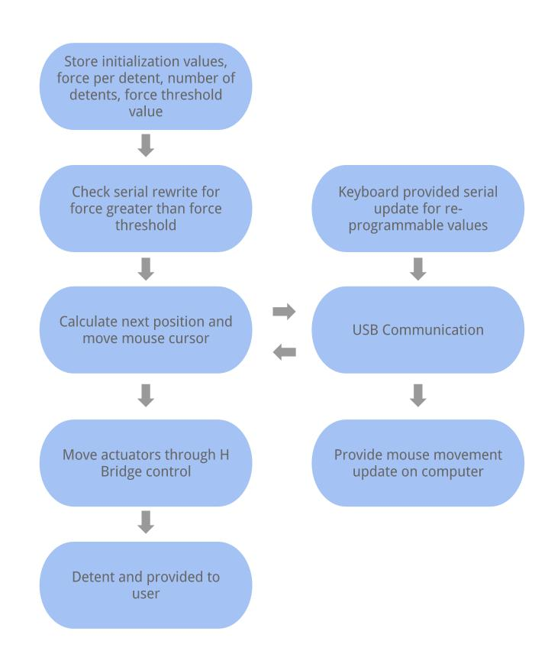

Software Development : Additional Features

Many additional features have been included beyond the initial design objectives. The addition of these features allow for the user to select how the joystick operates in different situations.
One feature is an optional mode of outputting keyboard arrow key navigation with or without cursor support. This feature can allow the joystick to function under conventional control in an isolated window, and provide equal response with every on screen movement. Also, this feature can be used with mouse support and ported to any other form of input on a computer.
One large area of aided support is for delays. Many delay controls are implemented throughout the code. Some delay parameters work across multiple functions, ones that cannot operate at the same time, such as the five selectable mouse routines while others scale to each individual operation such as mouse, keyboard, or pedal delays.

A list of delay features available in the code are as followed:
  - Cursor
  - Keyboard
  - Pedal
  - Cursor & Pedal
  - Joystick linkage:
  - Movement between detents
  - Feedback
  - Overshoot/undershoot

Five available feedback functions exist in the code. As implied earlier, many of these features are provided to expand positioning, but also allow for customizable feel over joystick movements. Each feature is modular and most are activated passively (with the exclusion of active feedback). A description of each is provided as followed:
    - Time Delay
    - Position
    - Overshoot/undershoot
    - Stress
    - Active

In addition five mouse modes exist as well. The purpose of the additional mouse modes is for users selection of what feels most comfortable/useable. A list of mouse functions and brief overview is as followed:
    - Click with user reprogrammable delay
    - Click once until pedal is released
    - Click once and waits for reprogrammable delay and then outputs a long click under the pedal is released
    - Click once and waits for release and if within reprogrammable delay will output a long click
    - Click once and waits for release and if within reprogrammable delay will output a long click; Also works for a click and waits for reprogrammable delay and then outputs a long click under the pedal is released

Given that the code has many features already, more implementation could easily be done. A couple features could expand user experience or completely change user experience such as completion of the sixth feedback option.
With the time window of this project the sixth feature did not get completed. Realization for this feature could be seen with positioning active when the applies a small force on the joystick, one less than the force threshold. This feature could increase the required effort needed to move the joystick allowing for a greater range of support for users. Another advantage could be seen with decreasing the play. The actuators would compensate for slack in the stroke every time the user moves the actuator. This feedback feature, not only needs more coding to see this realization but may benefit from additional hardware, seeing if the team had time to implement.

Additional hardware for the sixth feedback feature could provide cleaner operation for the active feedback mode. If a software switchable voltage divider could have been added to the h bridge the actuators could have had additional speed modes. These speed modes could work with providing accurate force in response to the force being exerted on the joystick. Extra sensors detecting the force could provide cleaner output for this feature as well if time allowed. These sensors could have been used specifically for this feature detecting movement right as the user provided force.

Another feature that could be implemented would be the use of a self-calibrating system. In this example the program could allow the user to reposition the joystick in any direction as the code takes an average of the maximum force threshold that the user puts the joystick under. This value could then be set as a new force threshold range for the user to control the joystick.

Though these functions may not have seen full development support by the teams work, the code is available to the community if anyone is interested in implementing these or other ideas into the code. Use of preexisting libraries may aide more functionality as possibilities of such additional support existing remains.

Software Development : Graphical User Interface(GUI)

When designing the user interface for the project, the team had to keep in mind the following goals :
- Must retain the functionality of all or the most important assisstive software the user needs in a single executable app or program.
- Must be a cross-platform solution, so that no matter what type of computer is used, the code can be compiled to run for the operating system.
- Must allow the end user to customize physical parameters of the joystick from the program without breaking workflow, being intrusive or needing programming knowledge.
- Should combine all of the above in a single simple and intuitive package.

To keep with the aforementioned software design goals, the team studied the most frequently used programs the end user might interact with. This was done to extract the core functionality of each type and possibly integrate this into the final solution.
The team organized and prioritized the findings as follows :

- The primary user of the project, Branden Bennett uses the Windows On-Screen keyboard to type into any other window. To ensure that he feels comfortable using the program, the team decided to build the core functionality around that of the default Windows On-Screen keyboard.
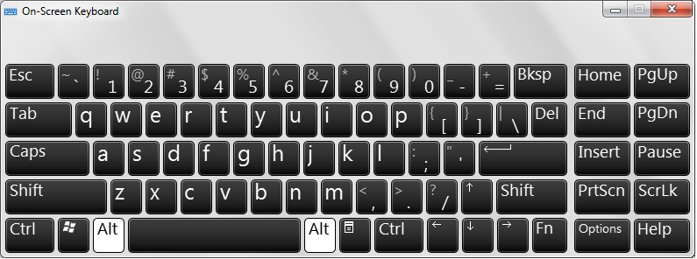
The Windows On-Screen Keyboard used by Branden

- Another key aspect that the team noted in the use of the Windows On-Screen keyboard was that it had predictive text input. However, if the user continously made a spelling error, it would suggest the mispelled word as well. To allow the user to have this functionality as well as provide a solution to the drawback the team found, the team decided to include a user defined dictionary into the core functionality.

- Jim Renuk is the Intramural Coordinator of Recreational Sports and Fitness Services at MSU and an individual with CP. He uses software to aid in speech such as BJBlabber(pictured below) and other Text-To-Speech(TTS) programs.

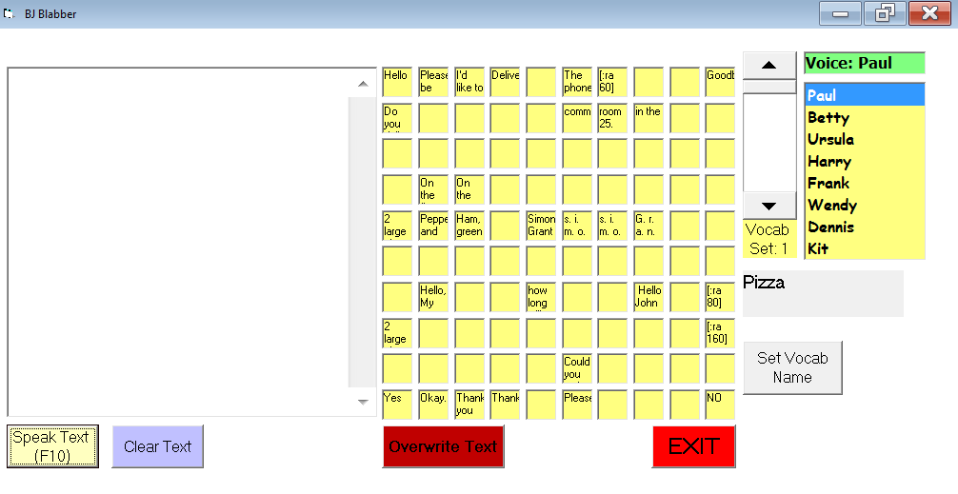

- The programs written by John Eulenberg to work with the mechanical model of the joystick(including BJBlabber) used a 10x10 matrix of words to make it easier for the 10x10 detented joystick. Functionally, the team did not need a matrix that scales depending on the number of detents since, the hardware is designed to function as a mouse to allow the user freedom of app choice, instead of being locked only to programs that recognize commands from a joystick.

While building the keyboard from the ground up(meaning that the team did not use pre built software to draw windows, animate the keyboard buttons, etc) and the team wanted a language that would support the major operating systems : Windows, Mac OSX and Linux. To facilitate both of these requirements, the team chose to use the visual programming language that inspired the arduino's IDE : Processing. Not only would Processing allow complete freedom over visual design of the GUI, but because it is built on JAVA, it would allow the team to use native JAVA code in Processing, extending the functionality and reach even further since JAVA is cross platform as well.
In accordance with the software design outline, the interface is built upon the following main blocks of code:

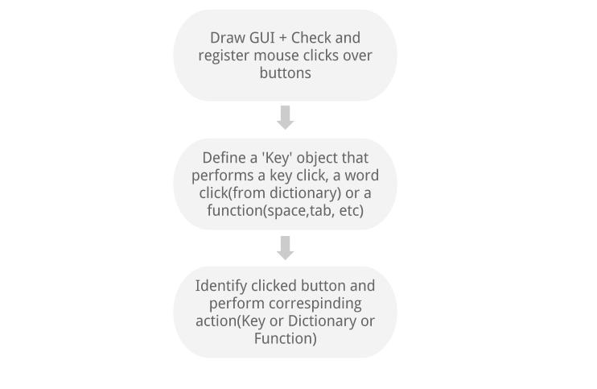
To make sure the buttons(drawn as rectangles) function as buttons in any other program native to the operating system, the team had to write code that would draw scalable buttons that detected when the mouse is over them and implements 'clicking'. The benefits of not using a library for such a mundane task, is that it opens the door to a lot of additional functionality. This includes changing the size, color width and shape of buttons in case the user has viewing problems. Also, a possible implementation which the team could not begin work on, owing to time constraints, was dynamically changing button size based on key usage. In other words, the more a user clicked a key over time, the bigger it would become to make it easier to click.

The overall functioning of the keyboard is shown on the next page :

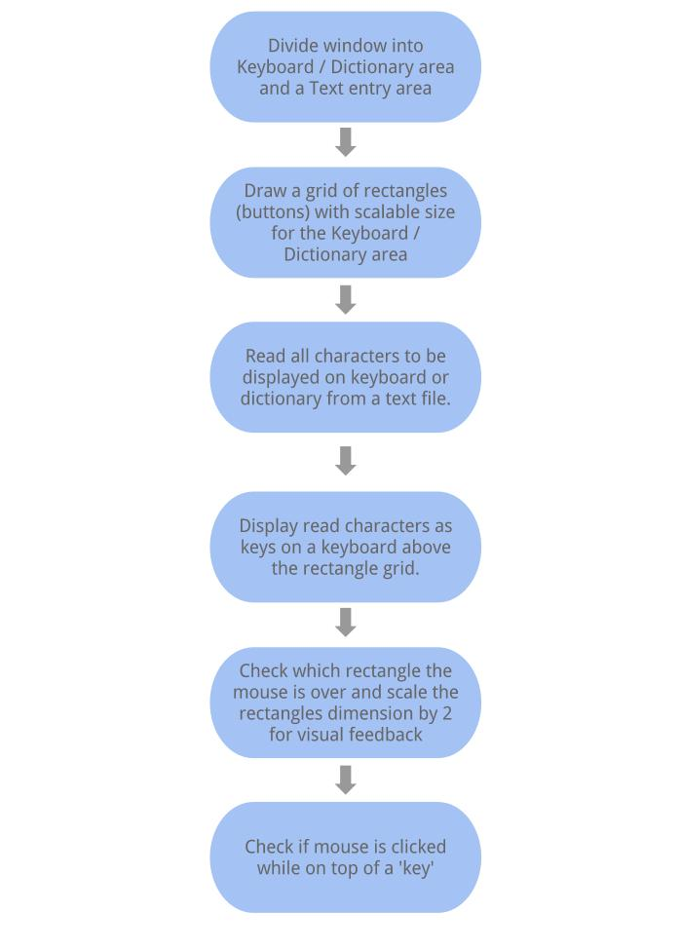

The keyboard makes use of JAVA's Robot library. The Robot library is usually used to generate 'fake' inputs to a computer for debugging and testing a program. However in the implementation, the team used this library to generate a corresponding 'key-event' each time the user clicks a key. This makes it easy to create a single button for functions that otherwise would need a combination of keys such as 'Control + left arrow' thereby giving the user greater functionality with greater ease of use that the Windows keyboard.

A defining feature and improvement over all the other programs used by the target user base is the inclusion of text-to-speech (TTS) functionality with the keyboard and dictionary. To achieve this in such a short time frame, while at the same time ensure that the sound library is available to the user no matter which computer is being used, the team decided to use Google Translate's TTS engine to power the keyboard's voice functionality. The program written converts the sound from Google Translate to an mp3 file and saves it to the computer for later use. To ensure that a large library of files could be used over time, the program uses an ultra low bitrate(2kB/s) to save files. For comparison a 3 minute long mp3 song file at 128 kB/s is around 3 MB. A 2 second long mp3 speech file saved using the keyboard is just 10 KB (1024 KB = 1 MB).

The functioning of this module is shown on the next page :
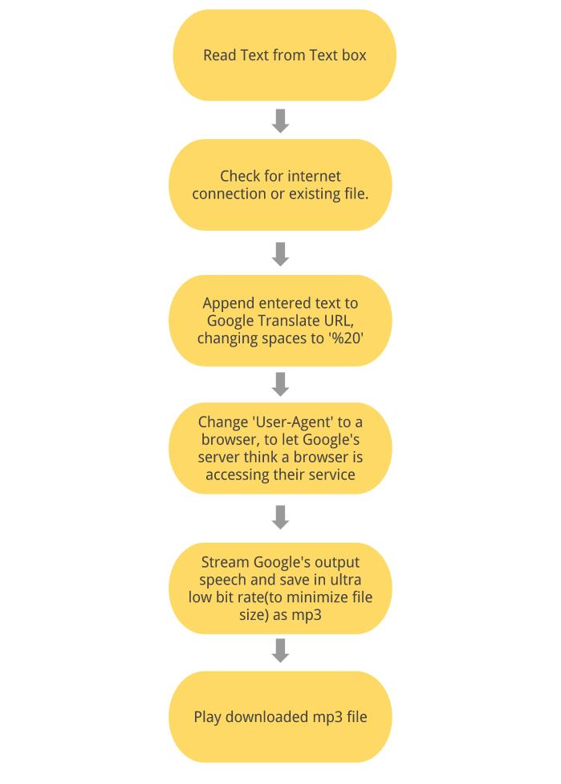

The final design of our GUI is shown below and is fully scalable to any window or display size/resolution :

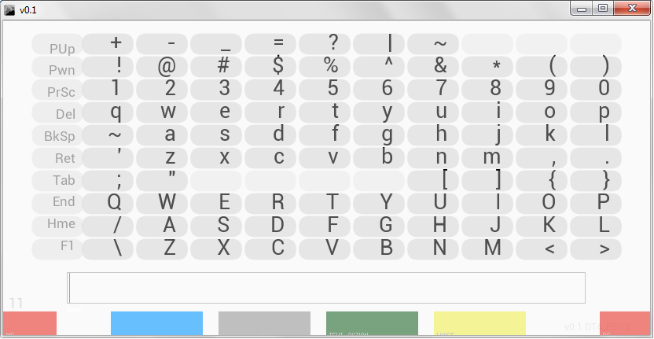

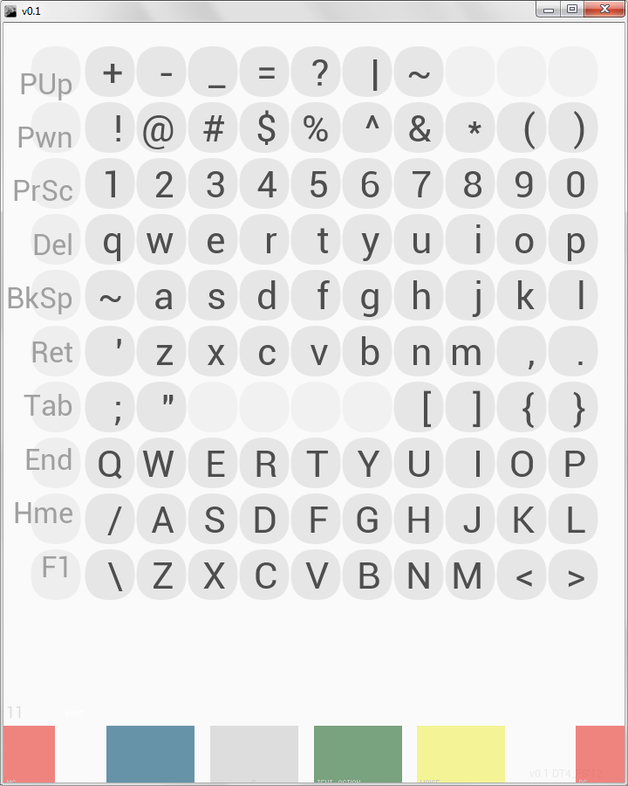

Debugging
Using serial println to see where bugs in code were
Used open-source code online to troubleshoot actuator movements or small programs found online
Testing wiring schemes to read positioning from actuators

Printed Circuit Board Design

Our PCB board is composed of the circuits that implements all our hardware design: H-bridge circuit, FSR drive circuit, power supply circuit with a shielded orientation. It is composed of H bridge chip, LM7808 chip, 25-pin headers and power jack along with resistors and capacitors. It is a one layer PCB board meaning that all the wiring connections could only been in a single layer.

Shield Design:

The Printed Circuit Board(PCB) is designed with the goal of making it shielded with the Arduino board, the other board of our design, thus making a sandwich board arrangement. The header-pins on our PCB will be inserted into the header-pin sockets on the Arduino board. This way we could save up lots of space used for the enclosure of our joystick, accomplishing the joystick with a reduced size of the current design.

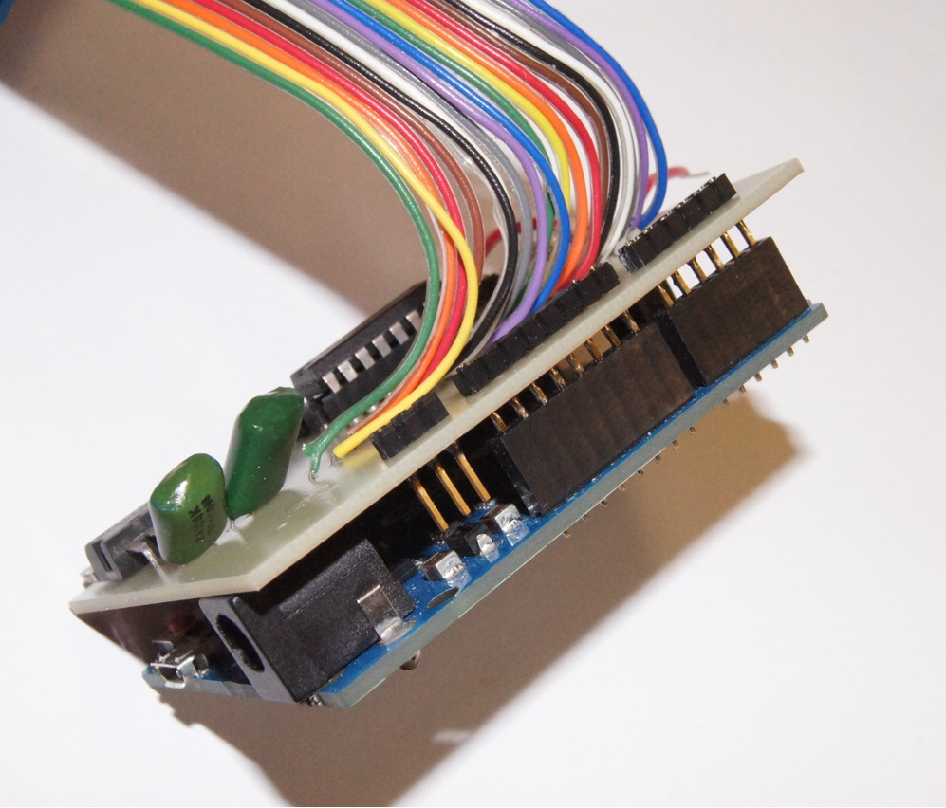

H Bridge Implementation:

The schematic of our H- bridge chip that is in charge of the actuator motor direction is shown below. For the specific functionality, refer to H bridge section on the Hardware design section in the beginning of this Chapter.

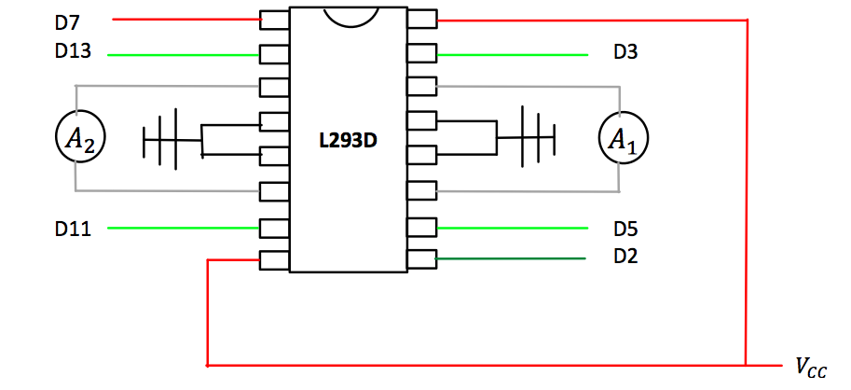
A1 and A2 output: Actuators (grey )
DX: digital pins on the Arduino boards (green)
Vcc: Power supply of 7.5V+ (red)
Other: Ground (black)

FSRs Pull Down Resistor Circuit:

Shown below is the FSR circuit that converts the resistance resulted from changing force to voltage readings that will be taken by analog inputs on the Arduino board. The circuit is fairly understandable. The FSR and an 10K resistor are in series connection with FSR terminal powered and resistor terminal grounded. Analog inputs reads the voltage in between resulted from changing of force.

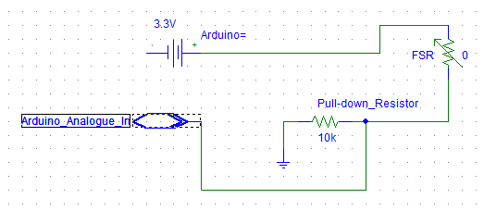

Power supply Circuit:

The power supply circuit stages down the external 16V power supply to 8V that we need with a L7808 chip. The associated circuit that is implemented on the PCB design is shown here:

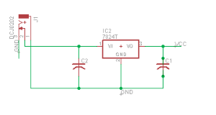

EagleSoft implementation and PCB Manufacturing:

The software used for the development of PCB is EagleSoft, which is one of the most commonly used PCB design software. EagleSoft generates the PCB board through mainly two editors: schematic editor and board editor where the two mainly steps are implemented: Schematic drawing and board tracing design.

Shown below is the result of our final PCB:

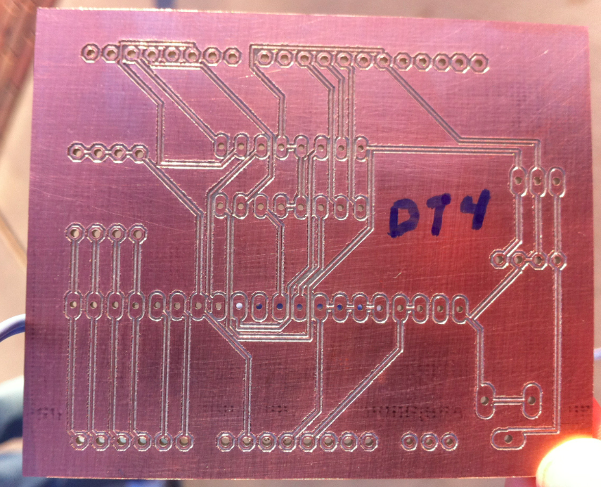

Wire Harness Connector:

The wire harness connector used is a 25-pin female and male connector that connects the actuators and FSRs that located inside the joystick box to the pins on the PCB board for interaction with other components on the PCB. It was made with the help of our sponsor Stephen Blosser.
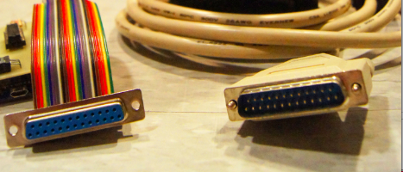

Wiring Harness Implementation:

It is particular essential to make sure of the correct wiring connections for our design as we are using a 25-pin connectors with both female and male headers that connects components inside the joystick enclosure to our PCB and Arduino board. Failure to do that would cause many unnecessary errors that might waste a long time to fix, more importantly, causing repairable damage to the boards. Therefore, we mapped all the pin connections of the connectors to make sure of the correct wiring harness connections.

Pin number | Shield color in male side | Connection in the PCB board | Shield color in female side
4 | Pink | FSR1 | Purple2
5 | Yellow | FSR2 | White2
6 | Green | A1 position pin | Brown2
7 | Light blue | A1 ground pin | Organge2
9 | Purple | A2 ground pin | Purple1
10 | grey | FSR power | White1
11 | white | FSR power | Brow1
12 | black | 3.3V | Orange1
13 | Brown/white | Ground | Green1
16 | Orange/white | fSR3 for A2 | Blue2
17 | Orange/black | FSR for A1 | Gray2
18 | Pink/black | A2 position pin | Black2
19 | Yellow/black | Acuators ground | Red2
20 | Green/white | A1 power | Yellow2
21 | Green/black | A2 power | Blue1
22 | Blue/grey | FSR power | Grey1
23 | Purple/white | FSR power | Black1
24 | Grey/black | 3.3V | Red1
Pin 1,2,3,8,14,15,25 | Not applicable | unused | Not applicable
Note: shield color1,2,3 counts from left to right

Chapter 4

Intended functionality of the Joystick

The prototype designed by the team was intended to take a lot of the mechanical components from the model of the mechanically detented joystick. Besides saving time, this allowed for a reimagining of space usage within the enclosure of the joystick, while at the same time keeping the end user’s experience feeling the same.

The overall functioning of the joystick is shown in the figure below.

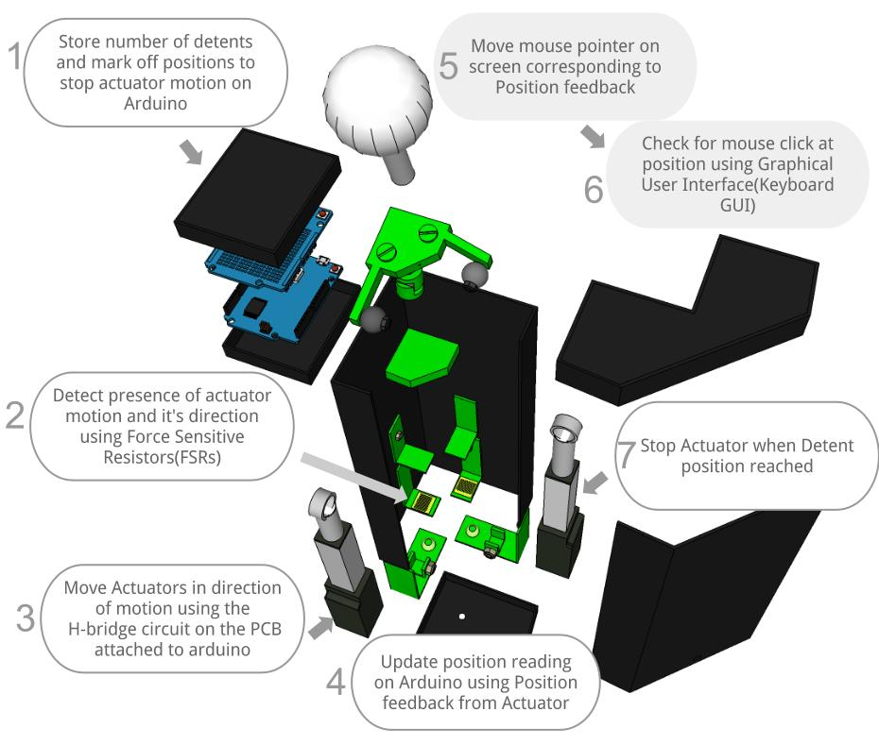

Testing for intended functionality

To test for proper functioning of the joystick, the team had to test for the following aspects :

- Changing the number of detents in the code of the Arduino, actually made the joystick physically stop at the same number of positions while being pushed along an axis.
- Stress testing the joystick for being pushed past a fixed ‘detent point’
- Heat generation by overpowering the joystick over a long period.
- Coordination between joystick motion and mouse movement on screen.
- Mouse motion when joystick is at physical extremes of axes position.

To test for proper functioning of the keyboard GUI the below points had to be checked for :
- Visual feedback on correct mouse motion and clicks
- Visual feedback and appropriate handling on illegal mouse or keyboard entries without resulting in program crash.
- Total Data file size over time should be less than a megabyte to allow for fast functioning even on older devices
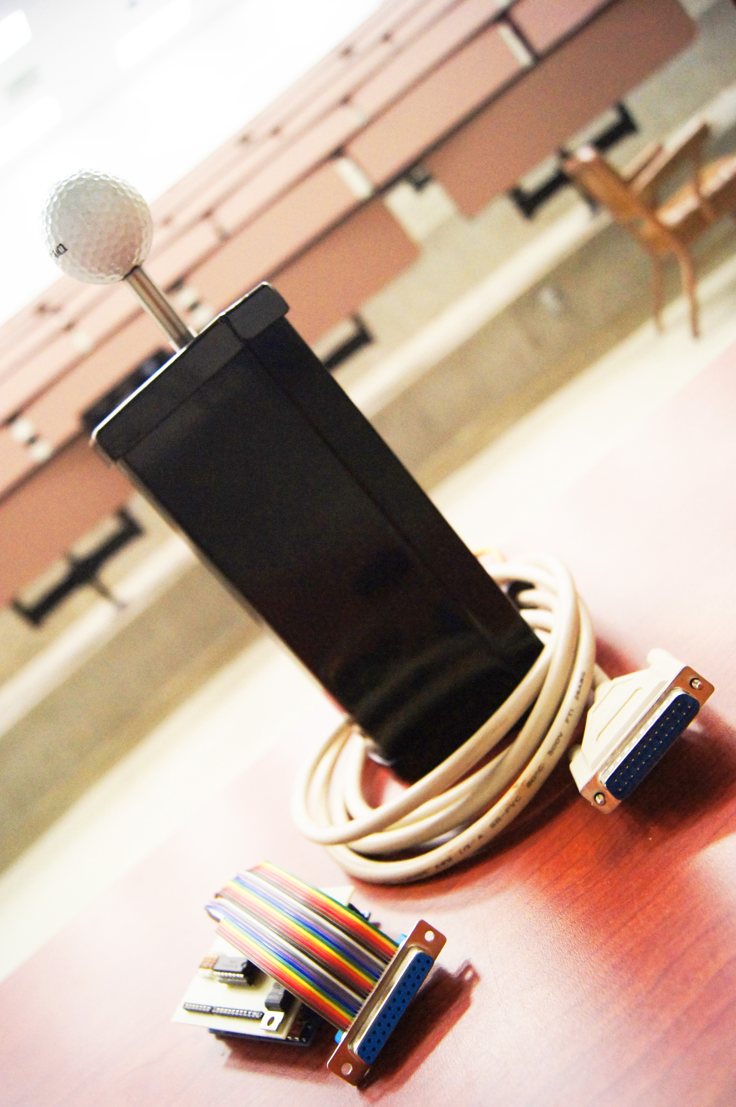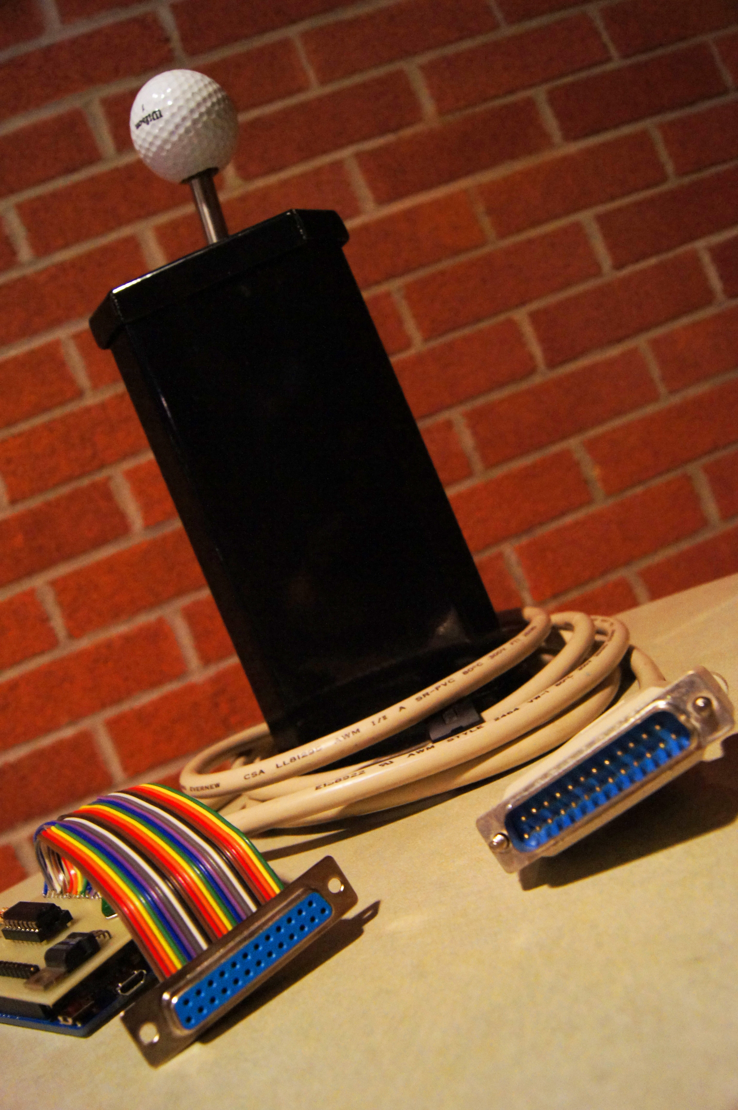

Test Results

Detenting

Testing detenting functionality was successful at all stages of prototyping as this was the first milestone in programming the hardware. Movement was registered in the software using the Force sensitive resistors(FSR). The output voltage would then be sent to the Arduino which would then converted to a value betweent 0 and 1024, using the onboard 10-bit Analog to Digital(ADC) converter. The same ADC was used for the output voltage from the Actuator’s position feedback pin. On average this value for the actuator’s position would range between 650 to 672 for a fully extended position and 0 for fully retracted.

Stress Testing

(Against a Duty Cycle of near 90%) Lot of went into minimizing heat generation on overcompensating the actuators’ force thresholds with different power supply voltages. The primary issue encountered was :
- When powered with 10V DC
  - Heat generated by the actuator casing would be hot to touch in around 7 minutes of heavy use.
  - Speed of actuator in responding to motion is high and ideal as it prevents latency in providing the detenting mechanism.
- When powered with 5 V DC
  - Heat generation was almost negligible
  - Speed of actuator response was too slow in cases of heavy use and resulted in excessive skipping of detenting positions.
- When powered with 7.5 V DC
  - Heat generation is minimal for around an hour of periodic motion.
  - Speed of actuator response was just adequate to provide detent force, though there is a slight latency if measured through the Arduino IDE. However, this wouldn’t be noticeable to an end user.
Hence the primary result of stress testing is a team decision to power the actuator with 7.5V DC.

Mouse movement and Actuator position

Moving the mouse is controlled by motion of the actuator. However, initial builds of the software resulted in extremely unusable mouse movements each time the actuator ‘detented’. This was something rectified early on through software. Ignoring mouse motions that are opposite to the direction of motion was how this issue was eventually resolved.

Another issue that resulted in a design/implementation change was the mouse motion when the actuator has reached its physical limits of motion along an axis. This was not an issue in previous mechanical models of the joystick, since the joystick was ‘locked’ into using programs designed to be used with it. Since the team’s design improves on this, by allowing the user the freedom that a mouse offers, while providing detenting, mouse motion had to be implemented in an intuitive manner.

The solution the team arrived at was to allow for mouse movement on screen even after the maximum extension of the actuator was reached along an axis. This was done because, at its limit, the purpose of detenting is served by the edge of the case. Hence the user already is provided with such a supporting force. Therefore, at any extreme of joystick position, the mouse continues to move in the direction force is applied till it reaches the edge of the screen, or the user applies force in the opposite direction, whichever comes first.

Software/Keyboard Graphical User Interface(GUI)

When designing the GUI a primary goal was to keep it intuitive and to allow the user to experiment with the GUI. To do this the team distributed the program at various stages to individuals outside the group. These individuals ranged from those with an engineering background to those from a visual design background to others with no technical background. The feedback received resulted in multiple changes to the look and feel of the GUI. The biggest change was in the design of the two halves of the window.

As shown in the above screenshot, The upper keyboard half would have a greyscale/monochrome design to stick with the theme of a regular keyboard while the bottom would have brighter colors that would imply a ‘different’ more ‘interactive’ use to the user. Such design changes were intended to provide maximum functionality while look eye-pleasing at the same time. Such a color based GUI removed the need to labeling on the buttons as well.

Another change was to remove the less used ‘function’ keys such as control, alt and F2 … F12. This was done to provide the user with the same functionality but with fewer keystrokes compared to the Windows On-Screen keyboard. As a result, both upper and lower case characters as well as special characters are all displayed on individual keys.

All voice functionality was built on the Google Translate service and are reproduced by downloading the audio and saving it as an mp3 file each time a voice output is requested. Initial builds of the software resulted in the folder size exploding to around 500 MB after creation of 75 audio and voice mp3s using the keyboard. After researching the working of mp3 files, the team decided to reduce the bitrate of downloaded mp3’s to 2 Kb/s from 256 Kb/s. The usual bitrate of >128 Kb/s only affects users if they intend listening to music. This is because when down sampling an audio file, the data that is lost is primarily from the lower (bass) spectrum. For our design, since the only audio the user will need to output will be a voice, the treble and midrange of the audio spectrum is all that is needed. Hence, reducing audio bitrate resulted in the same 75 audio files taking up only 150 KB while at the same time the voice quality was crisp and clear, even at louder volumes.

Chapter 5
Final cost, schedule, summary and conclusions

At the beginning of the semester, the team set out to update and improve on all aspects of an outdated piece of assistive technology: the mechanically detented joystick. For years, it had served as a vital piece of equipment to assist those with cerebral palsy in communicating, but there continued to be issues for some with the tuning and customization capabilities. With the inclusion of new electromechanical components and expanded microcontroller functionality, the goal was to accomplish the following three design objectives:

- Software-selectable number of detents
- Software-selectable detent force
- USB connectivity with PC or Mac

These objectives were indeed accomplished in the team’s new joystick design with the addition of several key new components: linear actuators, force-sensing resistors, an Arduino microcontroller board, and a selection pedal. The linear actuators took over as the detenting mechanism, allowing controlled motion in set increments based on force input. Force-sensing resistors were utilized in detecting force inputs on the joystick handle, signaling the actuators when a pre-determined threshold force had been registered. This essentially filters any unwanted muscle tremors. The microcontroller linked each of the mechanical components (see figure on page 40)and also provided the USB interface. This new joystick has the ability to function similar to a mouse for the user, and allows the user to input keyboard commands through a brand new graphic user interface that the team programmed and built from scratch.

These components proved functional in the design and were also cost-effective. The final design budget is shown in the table below with shipping costs added into each component total.
Prototype Component Costs
2 Firgelli linear actuators | 2 x $80.00
Arduino Leonardo w/ headers | $27.18
Arduino prototyping shield | $19.19
2.1 mm DC barrel socket | $13.60
Joystick housing | $0.00*
Power supply/Voltage regulator | $0.00*
Wiring harness | $0.00*
PCB/Additional circuit components | $0.00 (ECE shop)
H-bridge IC chip | Acquired as free sample from TI
Total Prototype Cost | $219.97
*Items provided by sponsor

It can be seen that the linear actuators contributed the largest portion of the budget by far at $160.00. The next biggest expense was the Arduino microcontroller board and a prototyping shield, used to implement some additional circuitry. These totaled at $46.37. Other than a PCB compatible dc jack for the power supply, the components used were acquired in house either through the team’s sponsor or the ECE shop. The grand total of the prototype came out to be $219.97, well under the budget of $500.00.

Throughout the semester, the team was able to follow the initial schedule fairly close. Initial meetings with the team sponsor were scheduled quickly in order to get a jump-start on the design process. All parts ordered arrived within a week, which kept from any large stalls in productivity. Some tasks took longer than expected, such as printed circuit board creation, but these slight delays could be made up for since the team had remained diligent during the semester.

In general, being able to meet each design specification set by the team sponsor was a great success; however, there were some other notable accomplishments this semester. One of the key successes of this design was implementing mouse functionality of the joystick. The previous technology allowed the navigation of a word selection matrix, where the new design allows the user to utilize the joystick similarly to a computer mouse. This locked the user into using programs designed solely for use with the old detented joystick. It was the inclusion of the linear actuators that provided the analog position tracking necessary to translate to mouse movement. Another key success was completing the design well under the budget constraint of $500.00. Taking advantage of available resources like Mr. Blosser’s machine shop, as well as opting to use FSRs in the design greatly reduced potential costs.

Having met the design specifications, there were not any outstanding failures of this prototype. Along the way, there were certainly some speed bumps, but overall, the team was able to accomplish the goals at hand. This is not to say that there are not improvements to be made in the future though. More could still be done beyond the scope of the initial design to improve the capabilities and performance of the joystick.

With a larger budget, higher end actuators could possibly be used to increase the detent speeds and also provide higher stability for the user. A larger budget could also allow the use of higher end force recognition methods with a greater level of precision. As far as software is concerned, the Arduino Leonardo platform allows for great possibilities with the joystick, including multiple threshold levels and position memory so it resets to a fixed position on the user’s command. Time ended up being a large constraint for implementing further functionality, but by utilizing completely open-source programming methods, future developers have solid groundwork to build upon. Suggested applications include further function key shortcuts on the keyboard as well as the inclusion of predictive typing similar to that of a cell phone. These are both ways to further improve the efficiency and simplicity of communication through a detented joystick.

The improvements made to the mechanically detented joystick were absolutely necessary in order to bring this type of assistive technology to a larger market. It provides a custom experience at an affordable cost. The new design opens the door for great possibilities in the future through an intuitive computer interface. Hopefully, this prototype will be the first iteration of many that allows a universal option of assistive technology for those living with cerebral palsy.

Appendix 1: Technical Roles

Scott Friedman, Team Manager


Scott’s technical contributions consisted of the physical construction associated with the electromechanically detented joystick. With his experience in mechanical design he worked closely with the team’s sponsor in developing the new joystick design. This paved the way for the software group to have a prototype for testing.

After the team conceptualized the two-actuator design, Scott primarily researched the sourcing of the Firgelli L16-50-35-12 linear actuators used for the design. The performance needs of the design required a small package, high no-load travel speed, and about 50N of back drive force. These requirements were a considerable challenge, especially the small package constraint.

Once the electronic circuitry was designed, Scott’s responsibility to the construction of the joystick continued with the soldering of multiple shield and printed circuit board designs. His leadership created an enjoyable team atmosphere, and his enthusiasm drove the team to work together effectively and efficiently.

Adi Mathew, Document Preparation


Adi played a large role on the software side of the development for the joystick. He was solely responsible for developing an intuitive graphics user interface for the joystick. His background in arts and visual design was just as valuable as his programming know-how in creating a software interface that will eventually be the only software part of this project that an end user will see. This involved large amounts of research and experimentation in order to get it right.

Adi’s attention to the little details in creating the interface was vital in ensuring that the program works flawlessly with the joystick. While putting in long hours developing the GUI, Adi also assisted Peter in the implementation of the Arduino microcontroller board. His experience with many facets of programming proved vital in completing the design.

Nate Hyde, Lab Coordinator


Throughout the design process, Nate worked on the research, testing, and implementation of the electromechanical components of the joystick. This included the two linear actuators as well as the force-sensing resistors. Initially, various design alternatives were explored for force sensing and linear actuation. He worked with Scott and Yongjiao to determine the optimal route through a careful analysis. Once a design plan was enacted and parts were in hand, he did some preliminary testing on the actuators to determine suitable operation voltage and speed settings. He also worked to find an ideal method to mount these components in the joystick housing. Other tasks Nate was involved with included creating a power circuit to operate the actuators above the five volts provided through the USB interface.

Another key objective Nate worked on with the help of Scott was creating the wire harness that linked the internal components of the joystick body to the external Arduino microcontroller and printed circuit board. This involved assigning connector pins and routing the wires in order to provide the necessary power and signal paths for the joystick components. This also involved carefully soldering the harness leads together with the corresponding actuator and FSR pins. Finally, he assisted in painting and assembling the mechanical portions of the housing.


Yongjiao Yu, Presentation Preparation

Yongjiao worked mainly on the hardware aspects of the team’s design. She contributed to research for force sensing technology, such as force transducers and FSRs, and played a role in communication with potential suppliers of design components. This process became essential in narrowing down design alternatives to choose the most effective one. She pursued several force sensing solutions before the team finally settled on using the FSRs.

Yongjiao’s biggest contribution came in the design and creation of a printed circuit board (PCB) containing much of the additional circuitry needed in the design. This included the H-bridge circuit to control the linear actuators, the power supply, and the FSR circuitry. The design of the PCB required her to thoroughly learn how to use the EagleSoft software. After its creation, she continued to lead the effort on testing and debugging of the PCB. During testing, she successfully identified a crucial error that was causing the joystick to function improperly.

Peter Ossian, Webmaster

Peter’s main responsibility was the creation and maintenance of the Arduino code. This is what controlled the actuators, FSRs and pedal. Much of the work consisted of calibration, which was done through software and hardware. In this part of the project, much adjustment of the FSR force ranges was needed to provide responsive and fluid joystick movement. He kept up with maintaining functionality while developing and updating code.

Much of Peter’s work went into creating functions that manipulate the actuators’ basic movements to expand the user’s control over the joystick. Other contributions Peter was responsible for were the migration to the H-bridge and the addition of the selection pedal. Through testing and debugging the code with the Linear Actuator Control boards in place, the need for navigating away from this approach was apparent and the constraints for an intermediary circuit were evident from his perspective of the project. He worked to gain familiarity with the H-bridge and eventually implemented the circuit, eliminating the need for the LAC boards.

Appendix 2

S. Blosser, ECE 480 Sponsor Liaison Meeting, 2221 Engineering Building, Michigan State University, Sept. 10, 2012

Atmel (2009, PDF) ATmega328 Data Sheet
http://www.atmel.com/dyn/resources/prod_documents/doc8161.pdf

Microchip (2007, PDF) PIC16F688 Data Sheet
http://ww1.microchip.com/downloads/en/devicedoc/41203d.pdf

Cerebral Palsy Fact Sheet, (2006,PDF) http://affnet.ucp.org/uploads/cp_fact_sheet.pdf

Youtube user : 'Vocaman' , "Visit with Jim Renuk Feb 9, 2011.wmv"
http://www.youtube.com/watch?v=2NqdFfBdXBw

http://www.robotshop.com/gorobotics/articles/microcontrollers/arduino-5-minute-tutorials-lesson-5-servo-motors

http://arduino.cc/forum/index.php?action=profile;u=2507;sa=showPosts)

http://store.firgelli.com/Firgelli_L12_P_p/l12-p.htm

http://processing.org/reference/

http://www.learningprocessing.com/examples/

http://www.sojamo.de/libraries/controlP5/

http://toxiclibs.org/

Appendix 3

The schematic drawing of our PCB board using EagleSoft is shown below: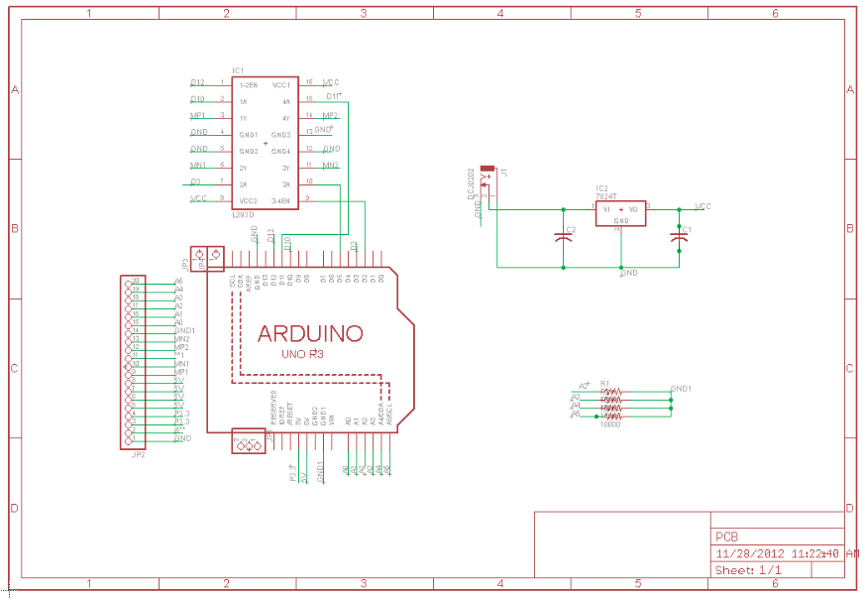

The board tracing generated from the wiring connections on the schematic:

